Glossary of Terms 2

Abstract 4

1.0 Chapter One: Introduction 5
1.1 Thesis Summary 5
1.2 Problem Definition 5
1.2.1 What Is a Benchmark and a Benchmark Suite? 5
1.2.2 The Place of This Project 8
1.3 Review Of Relevant Literature 9
1.3.1 Types of Benchmarks 9
1.3.2 Benchmark Suites 9
1.4 Overview of Thesis 11

2.0 Chapter Two: The Problem Facing Computer Research 12
2.1 What Is the Problem? 12
2.1.1 Misuse: Not All Are Equal 12
2.1.2 Abuse: Benchmark Cheating 13
2.1.3 Problems in Computer Research 15

3.0 Chapter Three: The Remedy 16
3.1 Rationale and Objective 16
3.2 What It Is 16
3.3 How It Was Done 16
3.3.1 Finding and Obtaining Benchmark Candidates 16
3.3.2 Preliminary Characterization of the Program 17
3.3.3 Modifications and Simulation Experimentations 17
3.3.4 Building the Distribution Website 19
3.4 Benchmarks Obtained 19

4.0 Chapter Four: The Details of the Project and Its Results 24
4.1 Relevant Theories and Definition of Terms 24
4.2 Discussion of the Project Features 25
4.3 Final Outcomes and Analysis of the Experimentation Results 27
5.0 Conclusions 29
5.1 Summary 29
5.2 Interpretation 29
5.3 Recommendations 30

Work Cited 31

Bibliography 33

Appendix: Time-Varying Behavior of Benchmarks 34

Glossary of Terms
Benchmark: A standard program one runs to judge the performance and behavior of the computer system.

Branch prediction: The microprocessor tries to predict whether the branch instruction will jump or not. It bases its prediction on the record in the branch history table of what this branch has done previously. The microprocessor uses this prediction to decide which instruction to load next into the pipeline, before it is certain. This is called speculative execution. If the prediction turns out to be wrong (a misprediction), then the processor has to flush the pipeline and discard all calculations that were based on this prediction. But if the prediction was correct, it has saved a lot of time [17].

Cache: A special high-speed storage mechanism. It can be either a reserved section of main memory (memory caching) or an independent high-speed storage device (disk caching).

Endianness: refers to the way data is referenced and stored in a processor’s memory. A system is little-endian if it stores the least significant byte at the lowest address in memory, or big-endian if it stores the most significant byte there.

Makefile: The file that the command “make” or “gmake” attempts to read when building a program. The makefile gives the instruction and information for building the program. It is composed of comments, dependency lines, directives, macros, response files, rules and shell lines.

Neural network: A type of artificial intelligence that imitates the way a human brain works by creating connections between processing elements, the computer equivalent of neurons. The organization and weights of the connections determine the output.

Out-of-Order [Instruction] Issue: refers to the out-of-order execution of instructions based on data dependencies rather than strict program order.

Pipelining: A technique used in advanced microprocessors where the microprocessor begins executing a second instruction before the first has been completed [18]. That is, several instructions are in the pipeline simultaneously, each at a different processing stage. The pipeline is divided into segments and each segment can execute its operation concurrently with the other segments. When a segment completes an operation, it passes the result to the next segment in the pipeline and fetches the next operation from the preceding segment. The final results of each instruction emerge at the end of the pipeline
in rapid succession.

Throughput: The amount of data transferred from one place to another or processed in a specified amount of time. Data transfer rates for disk drives and networks are measured in terms of throughput. Typically, throughputs are measured in Kbps, Mbps and Gbps.

Abstract

This thesis project builds and presents on-line a next-generation suite of computer benchmarks and their simulation experimentation statistics for computer research. The new benchmark suite features a collection of real applications. A benchmark is a standard program or test that one runs to judge and characterize the performance and behavior of a computer system. Different types of benchmarks exist, but in general, real applications make the most accurate, realistic, and thus useful, benchmarks. Benchmarking is an essential process in computer research as it enables computer performance analysis, characterization, and testing of new ideas in computer design, computer architecture, compiler development and other research areas. Unfortunately, despite their importance to computer research, publicly available benchmark suites are often unsatisfactory because they do not meet research needs, while better ones are often proprietary. Computer researchers therefore suffer from a lack of good benchmarks for assessing systems. While the benchmarking problem is not likely to be solved in the near future, this project makes a contribution to the solution by building and distributing an open-source, documented, next-generation suite of real-application benchmarks designed for computer research.

1.0 Chapter One: Introduction

1.1 Thesis Summary

A computer benchmark is a standard program that one runs to judge the behavior and performance of the computer system in use [1:28]. Benchmarks are thus essential tools in computer-design and computer-architecture research. Currently, there is a lack of publicly available computer benchmarks suited for computer research. This poses a serious problem to computer researchers, for accurate computer performance evaluation and prediction depends on dependable benchmarks. This thesis helps mitigating the problem by developing and distributing to computer researchers a much-needed real-application benchmark suite—a collection of benchmarks—suited to their needs.

1.2 Problem Definition

1.2.1 What Is a Benchmark and a Benchmark Suite?

Computer researchers must test computers for their performance and their behavior, and such tests require standards. Benchmarking can provide these standards. A benchmark is a test that measures the performance of a system or subsystem on a well-defined task or set of tasks. Benchmarks are commonly used to predict the performance of an unknown system on a known, or at least well-defined, task or workload. Benchmarks can also be used as monitoring and diagnostic tools. By running a benchmark and comparing the results against a known configuration, one may be able to pinpoint the cause of poor performance [4:2]. Similarly, a developer can run a benchmark after making a change that might affect performance to determine the extent of the impact [4:2].
Benchmarks are frequently used to ensure the minimum level of performance in a procurement specification. Rarely is performance the most important factor in a purchase, though. Performance benchmarks measure include graphics, I/O, computation (integer and floating point), and general performance (e.g., branch-predictions, instruction-execution, caching), but most measure more specific tasks such as rendering polygons, reading and writing files, or performing operations on matrixes [4:2-3]. Any aspect of computer performance that matters to the user can be benchmarked.
Despite the important role benchmarking plays in computer research, development of research-specific benchmarks has not received much attention. Different types of benchmarks exist today, each with its own strengths. Real-application benchmarks—actual programs that people use—are more accurate and useful, but they are often hard to obtain, due to proprietary issues. The difficulty and expense of building and distributing a non-profitable benchmark suite that includes a variety of real applications from wide sources, could be a reason why there is no website that provides them. As a result, there are currently few publicly available computer benchmarks that are truly useful for research purposes. Publicly available real-program benchmarks or benchmark suites that do exist (e.g., benchmark suites from www.specbench.org) are often poorly suited for research. They are often outdated, impractically long to run, or not representative of the computational demands of real applications. Other benchmarks are often kernels or synthetic benchmarks—neither of which offers accurate performance evaluation or prediction. Kernels are small, key parts from real programs, and are only useful for isolating the performance of individual features of a machine [2:20]. Synthetic benchmarks are artificial programs trying to match the average operands and frequency of operations of a large program set [2:20]. Synthetics are not only far from reality, but are also highly vulnerable to “cracking,” also known as “benchmark engineering” or simply cheating, in which measures to short-circuit or fast-forward the benchmark test are applied in an attempt to inflate performance measurements [2:47-48]. On the other hand, newer and better industry benchmarks are usually proprietary and thus are hard to access [3]. Social, geographic, and financial factors thus impede access to useful benchmarks for computer research. Without good and easily accessible benchmarks with which to test and evaluate designs and ideas, computer research is thwarted.
A visit to the supervisor of this project, Dr. Kevin Skadron, assistant professor of computer science at the University of Virginia, brought to light the significant problem with benchmarking in computer research. This project attempts to resolve the benchmark problem by building and distributing an open-source suite of up-to-date benchmarks specifically designed for computer research. The special set of benchmarks, with simulation experimentation results and documentation for reference, will be readily accessible on-line to everyone. Computer researchers will benefit from more convenient and accurate performance evaluation and system characterization with the tools that this project provides.
The project will ease computer performance analysis by offering a free, comprehensive and up-to-date suite of benchmarks that anyone can download. No longer would social, geographic, or financial factors be inhibitors to obtaining useful benchmarks for computer research. This project ultimately promotes equality and freedom in computer research by distributing free yet good research benchmarks to which everyone can contribute and which everyone can obtain.
This project also contributes to researchers in other fields. Facilitating computer research with free, good and easily accessible testing and measurement tools, the project will help improve processor design. As processors improve, any field of research that uses heavy computational resources will also benefit.

1.2.2 The Place of This Project

This project builds and distributes for free a next-generation suite of computer benchmarks tailored for computer research. This project takes advantage of academic institution affiliation. It seeks real applications from a diverse set of computational applications from different research groups mostly at the University of Virginia. Other good, real-application benchmarks from scattered, little-known websites were assembled through Internet research. This project seeks out and collects as many useful real applications as possible, evaluates and tests them with simulations, and finally groups them in a documented suite that can be downloaded. Candidates for benchmarks are computationally complex, represent real-world applications, are portable to multiple platforms, and resist the “cracking” that inflates performance measurements [2:48].
Unlike other publicly available benchmark suites, this one consists of all real applications. They represent some of the computational programs that researchers in different fields use today. They have sophisticated computational demands that test the limits and behavior of the processor. Compared to synthetic benchmarks created to match an average execution profile [2], these new benchmarks evaluate performance while resisting the benchmark engineering that bends the results.

1.3 Review Of Relevant Literature
A variety of methods and metrics have evolved over the years for evaluating, measuring, and reporting computer performance. In measuring computer performance, the two most common metrics are execution time and throughput. Each of them looks at performance from a different perspective and interest; nonetheless, both center on the key measurement of time [2:18].

1.3.1 Types of Benchmarks
Patterson and Hennessy contend that the only consistent and reliable performance measurement is the execution time of real programs [2:18]. According to them, there are four different levels of benchmarks for judging computer performance and characterizing system behavior [2]. In decreasing order of performance prediction accuracy, the four levels of benchmarks are: real programs, kernels, toy benchmarks, and synthetic benchmarks [2]. Real programs (e.g., C compilers) have input, output, and offer user options when running the program. Since they are actual programs that people use, they can realistically evaluate computer performance. At the other end of the accuracy spectrum are their artificial counterparts—synthetic benchmarks. Synthetic benchmarks try to match average operands and operation frequency of a large program set; however, as artificial creations, they are incapable of giving realistic evaluation of computer performance. Thus synthetic benchmarks are not useful for performance evaluation.

1.3.2 Benchmark Suites
Jozo Dujmovic and Ivo Dujmovic suggest that evaluation of a computer system always involves execution time of the particular workload—the combination of programs and operating system commands that users run on a machine [5]. Recently, collections of programs have emerged as benchmark suites to characterize the performance of processors with a variety of applications [2:21]. The advantage of using a benchmark suite over individual benchmarks is that the suite as a whole neutralizes the weakness of any one benchmark. However, benchmark suites also complicate ensuring the proper mixture of programs for the workload. Different approaches exist to balance unequal program mixture in the workloads of benchmark suites. The weighted arithmetic mean assigns a weighting factor to each program, and the geometric mean normalizes execution times to each machine [2:26-27]. Jozo Dujmovic discusses compound workload characterization by the computation of “global indicators” from individual benchmark execution times and appropriate weights [6]. The SPEC benchmarks use the geometric mean method. Although both approaches resolve the issue of achieving a balanced workload, they each have drawbacks that researchers are trying to solve.
Most recent research in the development of computer benchmarks is highly specialized, targeting specific areas only. Berry published his research in the assessment of the significance of installation tuning factors using variance statistical modeling in an IEEE paper [6]. The paper presents an interesting case study of applying the statistical design of benchmarks and experiments to computer performance analysis. Other, more advanced topics on benchmarking include the theoretical concepts, design, and use of universal benchmark suites to reduce benchmarking cost [5]. There is a growing effort among researchers to transform benchmarks to fit current technologies and conventions. For example, Welch and Shirazi developed DynBench, a dynamic real-time benchmark for assessment of Q0S and resource management technology, for use in a computing era dominated by real-time distributed systems [8].
Some researchers are trying to develop an effective framework for benchmarking. Hockey emphasizes the importance of choosing the correct performance metric, and defines the temporal, simulation, benchmark and hardware performance metrics [9].
Publicly available benchmarks that are satisfactorily tailored for computer research purposes are scarce [3]. The lack of such essential research tools creates a real and urgent need for next-generation benchmarks that are accessible to all.

1.4 Overview of Thesis

The rest of the report documents the creation of the new benchmark suite, from application gathering to preliminary characterization, modifications, simulation experimentation, and final distribution. The thesis reports on the final product and experimentation results of simulations of the benchmarks using the simulators SimpleScalar[10] and HydraScalar[11]. Analysis of the statistical data collected from the simulation experiments will also be included. This thesis documents the applications that are posted on the web site. Finally, a summary that evaluates the successes and failures of this thesis, interpretation of the data, and recommendations for future extension of the project, conclude the report.

2.0 Chapter Two: The Problem Facing Computer Research

2.1 What Is the Problem?
Although there is a broad range of benchmarks available, because of the selective nature of computer research, only real-application benchmarks are truly useful for it. However, real-application benchmarks are rarely publicly available.

2.1.1 Misuse: Not All Are Equal
Computer research, such as computer architecture and design and compiler research, often studies the behavior of computer systems in detail. Researchers need means to inspect how their new designs affect system performance and behavior. Running a program (benchmark) on a simulator that can mimic the characteristics of particular computer systems. The simulator can be a piece of software. In this case, we are running a piece of software on another that simulates a processor. The simulators are often written to output useful statistics (e.g., number of instructions executed, number of conditional branches encountered, the conditional branch prediction hit rate, miss rates) for studying the system behavior. Benchmarks can provide realistic estimates of crude performance and potential performance, a system's likelihood of crashing, and the performance capabilities of large systems. A diverse assortment of benchmarks is available, ranging from free benchmarks on the Internet to benchmarks that cost more than 10,000 dollars[12]. Most of these non-proprietary benchmarks today are of either the kernel or the synthetic types, which are not ideal for computer research.
Benchmarks are widely used—and often incorrectly. We often equate a benchmark’s raw performance with its productivity—faster must be better—without bothering to ascertain what the benchmark is actually testing. In reality, there is a big difference between performance and productivity and an equally large variation between different types of benchmarks. Benchmark categories include system instrumentation, low-level, API and application [13]. Application benchmarks (e.g., VITS, VidMark, WinTach, San Diego Benchmark, and the AutoCAD-specific application benchmarks) evaluate the performance of the entire computer system running the specific application. Accurate system assessment requires access to the entire data set produced by the benchmark, thus making application (especially real-application) benchmarks the most accurate. API benchmarks isolate the testing to individual computer components, without necessarily indicating the effect of that component on overall system performance. Examples of API benchmarks are PC Magazine’s WinBench/WinMark, or the Torque, Speedy, and PowerMark benchmarks. Manufacturers love to quote the numbers from these benchmark tests, especially when the test produces big numbers; however in reality, API benchmarks are a very doubtful measure of productivity due to their susceptibility to benchmark cheating. Low-level benchmarks also test the performance of individual system components, but do so by measuring raw performance at a much more basic level. They often access the hardware directly, bypassing the operating systems, hence yielding surprising but unreliable statistics. System instrumentation benchmarks, while useful in tuning the performance or productivity of an individual system, provide virtually no statistics useful in the comparison of different systems.

2.1.2 Abuse: Benchmark Cheating
Many vendors have been accused of benchmark cheating—designing or altering products to excel at benchmark testing rather than in real-world performance. Means of cheating include subverting the benchmark test by slipping in machines with faster clock crystals, stuffing the system with faster RAM (Random Access Memory), and eliminating wait states to speed things up. PC Magazine, famous for its WinBench (an API benchmark), has encountered many such attempts by manufacturers who tried to take a shortcut on the road to success (a good score or the coveted Editors’ Choice award can be worth millions of dollars in business) [14]. A well-known incident was the infamous “Chang” modification, a secret technique used by an engineer in Taiwan to slow down a system’s real-time clock (hence throwing off the benchmarking program), which therefore boosted perceived speed by 50 percent in modified 286-based PCs [14]! In another instance, a handful of graphics card companies were tailoring their card drivers to yield better WinMark (also an API benchmark) results without improving actual performance. The developer of WinMark therefore announced a new version of WinBench and stated that manufacturers would have to submit their boards to Ziff Labs for testing before they could publish the results [14]. This was one of the most visible instances of benchmark cheating, but certainly just the tip of the iceberg.
Ben Myers of Spirit of Performance Inc., a consulting firm that specializes in benchmarks and which is responsible for PC Magazine's Windows benchmark, likened computer benchmarks to the old cartoon “Spy vs. Spy,” in which two spies constantly try to outwit each other. Vendors attempt to figure out what a benchmark does and then make the benchmark run faster with the vendor's products; benchmark developers then counter with more sophisticated tests, and vendors counter with more attempts to break the benchmark, and so on.
In reality, performance is only part of a larger equation. Performance may be quantified by a benchmark, but it is impossible to quantify productivity that is truly subjective. Choosing the best system for running a large, computation-intensive application, be it AutoCAD, Pro/Engineer, or Softimage, requires fine-tuning of the individual system components and careful attention to the types of tasks that are to be performed [13]. Running a benchmark well requires an understanding of how to interpret the benchmark results.

2.1.3 Problems in Computer Research
Computer researchers need tools to evaluate systems and to test designs. The study of processor technology or computer architecture requires an understanding of how different designs behave in real applications. Simulations or tests with real-application benchmarks are then the most effective ways to obtain such information. Unlike large-scale, well-funded commercial computer systems development, academic computer research often involves more theoretical studies with less money. Therefore, most of the commercial benchmarks available, which are tailored for industry testing, do not meet research needs. Besides being impractically large-scale for research use, those API, kernel (or synthetic benchmarks) are often too costly for average academic computer researchers. Financial, sociological, and geographical backgrounds should not be limiting factors that curb advances in research. Essential tools such as useful benchmarks should be conveniently available to computer researchers at little or no cost.

3.0 Chapter Three: The Remedy
This project helps resolve the benchmarking problem in computer research with a real contribution. Here is the Next-Generation Benchmark Suite overview.

3.1 Rationale and Objective
This thesis project builds and provides a up-to-date suite of open-source application benchmarks for computer researchers to use. Useful applications received preliminary characterizations and simulation experimentations. The simulation results along with the source code and documentation will be available on a new web site. This project thus proposes a practical solution to the lack of public application benchmarks by providing a suite of them on-line.

3.2 What It Is
This open-source benchmark suite consists of real applications that researchers use today. For instance, one such program computes higher statistics for texture recognition; others include models of neural networks. These applications make sophisticated computational demands that allow researchers to assess the behavior of the processor being simulated or tested.

3.3 How It Was Done

3.3.1 Finding and Obtaining Benchmark Candidates
Most applications were obtained from researchers at the University of Virginia. Others were obtained from Internet sources. By searching the Internet for related articles and interviewing researchers, computationally intensive programs applicable to this project were selected. Because of their portability, programs written in C, Fortran, and Java made good candidates for this project. Owners of the selected applications were contacted to negotiate contributions of application source code. The purpose of this research project was explained to them so that all contributions were made voluntarily.

3.3.2 Preliminary Characterization of the Program
A preliminary characterization followed the acquisition of each program. This included an investigation of the purpose and the key algorithmic components and data structures of the program. Complexity increases with the level of detail in the description of data structures, especially when the code is not written clearly and intuitively. Basic knowledge of the major algorithm and data structure is helpful in understanding how the program interacts with the computer system during simulations. For example, a program with a main loop that calls a function that repetitively stores or retrieves data in a hash table would heavily use the caching (a way of fast data access) of the processor; on the other hand, a program with numerous if/else conditional statements would invoke more conditional branching in the processor.

3.3.3 Modifications and Simulation Experimentations
Necessary modifications and compilations were made to the programs for porting to different Unix platforms and for running simulations. These included applying the f2c (Fortran-to-C) program to transform a Fortran program to the C version, and compiling the benchmarks with a special version of gcc compiler for simulations. Next, processor-related statistics were collected by running the benchmarks on simulators. Two related software-based simulators were used, each for different purposes. One of them was SimpleScalar, a suite of free, publicly available simulation tools created by computer science researchers at the University of Wisconsin Madison [10]. The other was HydraScalar, created by Kevin Skadron as a derivative of SimpleScalar with an improved pipeline and cache models [11]. SimpleScalar was used mainly to collect statistics for branch-prediction information. However, I had to make some minor modifications to the SimpleScalar’s sim-bpred (a branch prediction processor simulator) for optimal usefulness. sim-bpred originally tracked branch-prediction accuracy for all control-flow instructions (conditional branches, unconditional jumps, etc.). This was too inclusive to be useful, since the project was interested only in conditional branches. Therefore, changes were made to several files in the package in order to collect the desired statistics. HydraScalar was used to collect statistics for instruction-execution throughput, cache behavior, and time-varying behavior, which could be generated as two-dimensional graphs.
The simulation experiments could be very time-consuming, taking anywhere from one clock second (one second according to the system clock) to several days to run to completion. The length of the simulation depended on the number of instructions invoked and the extensiveness of the statistics collected (the “target”). All of the simulations were run on Unix platform, using the time-sharing machines available from the Computer Science department at the University of Virginia. Inevitably, the amount of processing resources the simulation jobs would get was uncertain, and changed dynamically depending on the activities of the other users of the system. To avoid arbitrarily dominating the system resources, all of the simulations were invoked with the Unix nice command, which sets its argument (the simulation) to a lower priority, reserving the CPU resources to all other higher-priority tasks (being “nice” to the others). This sometimes increased the total processing time dramatically when there were other (higher-priority) computationally intensive tasks running on the same machine.

3.3.4 Building the Distribution Website
For each benchmark in the suite, this project has created a web page (http://www.people.virginia.edu/~skc2s/benchmarksuite.html) with a description of the program’s purpose and basic algorithm. Depending on the complexity of program interpretation, sometimes a brief description of the major data structures is included. Also provided were links to all the relevant files, including a Makefile, and instructions on how to compile the benchmark for SimpleScalar and HydraScalar.
Basic statistics from the simulations were reported on the web site. These include the number of instructions executed, IPC (instruction per cycle) for the two specific HydraScalar configurations, the conditional branch prediction rates for each sim-bpred configuration, the miss rates for L1 (level 1) D-cache (data cache), L2 (level 2) I-cache (instruction cache), and L2 unified-cache, for each of the two HydraScalar configurations. Plots of the branch prediction and L1 D-cache interval conditional miss rates generated from the sim-missr simulator and graphed by the gnuplot tool from Sun’s Unix platform, are also on the web page.

3.4 Benchmarks Obtained

A total of nine programs (in C) were included. One of them was a program written by Thomas E. Hall to perform texture recognition using higher statistics [15]. Hall holds a Ph.D. in electrical engineering, and he is now on the staff at the Research Computing Lab of the University of Virginia Information Technology and Communication center. Eight different models of neural networks constitute the rest of the benchmark suite. The sizes of the programs range from less than 8000 to more than one billion instructions (See Table 1-2 for the documentation for each program).
Network | Application | Description
ADALINE  Adaline Network | Pattern Recognition  Classification of Digits 0-9 | The Adaline is essentially a single-layer backpropagation network. It is trained on a pattern recognition task, where the aim is to classify a bitmap representation of the digits 0-9 into the corresponding classes. Due to the limited capabilities of the Adaline, the network only recognizes the exact training patterns. When the application is ported into the multi-layer backpropagation network, a remarkable degree of fault-tolerance can be achieved.
BPN  Backpropagation Network | Time-Series Forecasting  Prediction of the Annual Number of Sunspots | This program implements the now classic multi-layer backpropagation network with bias terms and momentum. It is used to detect structure in time-series, which is presented to the network using a simple tapped delay-line memory. The program learns to predict future sunspot activity from historical data collected over the past three centuries. To avoid overfitting, the termination of the learning procedure is controlled by the so-called stopped training method.
HOPFIELD  Hopfield Model | Autoassociative Memory  Associative Recall of Images | The Hopfield model is used as an autoassociative memory to store and recall a set of bitmap images. Images are stored by calculating a corresponding weight matrix. Thereafter, starting from an arbitrary configuration, the memory will settle on exactly that stored image, which is nearest to the starting configuration in terms of Hamming distance. Thus given an incomplete or corrupted version of a stored image, the network is able to recall the corresponding original image.
BAM  Bidirectional Associative Memory | Heteroassociative Memory  Association of Names and Phone Numbers | The bidirectional associative memory can be viewed as a generalization of the Hopfield model, to allow for a heteroassociative memory to be implemented. In this case, the association is between names and corresponding phone numbers. After coding the set of exemplars, the network, when presented with a name, is able to recall the corresponding phone number and vice versa. The memory even shows a limited degree of fault-tolerance in case of corrupted input patterns.
CPN  Counterpropagation Network | Vision  Determination of the Angle of Rotation | The counterpropagation network is a competitive network, designed to function as a self-programming lookup table with the additional ability to interpolate between entries. The application is to determine the angular rotation of a rocket-shaped object, images of which are presented to the network as a bitmap pattern. The performance of the network is a little limited due to the low resolution of the bitmap.
SOM  Self-Organizing Map | Control  Pole Balancing Problem | The self-organizing map is a competitive network with the ability to form topology-preserving mappings between its input and output spaces. In this program the network learns to balance a pole by applying forces at the base of the pole. The behavior of the pole is simulated by numerically integrating the differential equations for its law of motion using Euler's method. The task of the network is to establish a mapping between the state variables of the pole and the optimal force to keep it balanced. This is done using a reinforcement learning approach: For any given state of the pole, the network tries a slight variation of the mapped force. If the new force results in better control, the map is modified, using the pole's current state variables and the new force as a training vector.
ART  Adaptive Resonance Theory | Brain Modeling  Stability-Plasticity Demonstration | This program is mainly a demonstration of the basic features of the adaptive resonance theory network, namely the ability to plastically adapt when presented with new input patterns while remaining stable at previously seen input patterns.
Perceptron | Artificial Intelligence Concept-Learning | The perceptron is a program that learn concepts, i.e. it can learn to respond with True (1) or False (0) for inputs we present to it, by repeatedly "studying" examples presented to it. The Perceptron is a single layer neural network connected to two inputs through a set of 2 weights, with an additional bias input. Its weights and biases could be trained to produce a correct target vector when presented with the corresponding input vector. The training technique used is called the perceptron learning rule, which has been proven to converge on a solution in finite time if a solution exists. The perceptron calculates its output using the equation: P * W + b > 0, where P is the input vector presented to the network, W is the vector of weights and b is the bias.
Table 1. Description of the neural networks
Program | Application | Description
ARMAest22e | Image Modeling Auto-Regression Moving Average modeling | This program models images with 2-D Auto-regressive moving average, by estimating the parameter to reconstruct the image. It conveys the 2-D image input with a 2-D noise array and random number sequences to generate the AR model. Monte Carlo simulations running the algorithm compute higher-order statistics; each run does a new parameter estimate of the original parameter, where each pixel value is based on the original pixel value and some noise.
Table 2. Description of armaest22e

The next chapter explains relevant theories and defines terms, reports the simulation statistics output, and analyzes experiment results. The last chapter includes a concluding summary, data interpretation, and future recommendations for the project.

4.0 Chapter Four: The Details of the Project and Its Results

This chapter presents the benchmarking project in detail and reports the final outcome and experimentation results.

4.1 Relevant Theories and Definition of Terms
The purpose of benchmarking is to assess computer system performance and behavior. One practical way to evaluate a system is by running a benchmark representing a realistic workload on the system (real or simulated) and gathering statistics on system behavior. Depending on the area of interest, different sets of statistics can be gathered with different simulation packages. This project collected statistics about branch-prediction, instruction-execution throughput, cache behavior, and time-varying behavior. SimpleScalar (Version 2.0) and HydraScalar (a derivative of SimpleScalar developed by Dr. Kevin Skadron of the University of Virginia) were the two simulation packages used in this project.
The SimpleScalar tool set is available online at http://www.cs.wisc.edu/~mscalar/simplescalar.html. The tool set consists of compiler, assembler, linker, simulation, and visualization tools for the SimpleScalar architecture—a derivative of the MIPS architecture [10]. To improve portability, the tool set defines both little-endian (sslittle-na-sstrix) and big-endian (ssbig-na-sstrix) architecture versions to match the endianness of the host machine. (Endianness refers to the way data is referenced and stored in a processor’s memory.) The order of storage varies in different systems. The little-endian system stores the least significant byte at the lowest address in memory, while the big-endian system stores the most significant byte there [16]. The tool set can simulate programs (benchmarks) on a range of modern processors and sytems by taking binaries compiled for the SimpleScalar architecture and simulating their execution on one of the five execution-driven processor simulators. The processor simulators range from a fast functional simulator (sim-fast) to a detailed, out-of-order issue processor (sim-outorder) that supports non-blocking caches, speculative execution, and state-of-the-art branch prediction [10]. The tool set is partly based on supporting tools from the GNU software development utilities [10]. It provides researchers with an easily extensible, portable, high-performance test bed for systems design. HydraScalar is derived from SimpleScalar, with improved pipeline and cache models. HydraScalar also includes a simulator to produce interval-miss-rates over time.

4.2 Discussion of the Project Features
The benchmarks were compiled with the big-endian version of gcc and simulated on the Sun Microsystems machines. Some of the simulations made use of makefiles (normally used for compiling files, but here used to invoke a series of simulations with specifications) configured to run a segment of simulations. Others were invoked directly with configuration files or commands containing the simulator-dependent options and their arguments. Each simulation output was usually redirected to an output file. Different simulators collect different sets of statistics, so each benchmark required several different simulations. The basic statistics on which the simulation experiments of this project focused included: total number of instructions executed, instructions per cycle (IPC) for each of the two hydra configurations (hydra is a multipath-capable, out-of-order issue, cycle-level simulator of the HydraScalar tool set); conditional branch prediction rate for all the branch prediction configurations defined in the invoking makefile; and the cache miss rates for level 1 data cache (L1 D-cache), level 1 instruction-cache (L1 I-Cache), level 2 unified-cache (L2 U-cache).
With some large programs, the simulations took more than a week, largely because the programs were running on top of a simulator that is all software. The simulator used—thus the set of statistics being collected—also determines the length of the simulation.

4.3 Final Outcomes and Analysis of the Experimentation Results
The simulation statistics collected are listed in a table (Table 3). The time-varying behavior of the programs is graphed as interval conditional-misprediction rate versus the number of instructions executed (Figs. 1 – 8 Appendix).
 | # instr |  | IPC |  | Bpred_cond_rate |  |  |  |  |  | L1 D-cache |  | L1 I-Cache |  | L2 U-cache
Benchmark | from sim-fast | from hydra | hydra 4w | hydra 8w | Bim_8k | Gag_1_32k_15 | Gas_1_32k_8 | Gas_1_8k_6 | Pas_4k_32k_4 | Pas_1k_32k_4 | 32 KB 4 way | 32 KB 8 way | 32 KB 4 way | 32 KB 8 way | 32 KB 4 way | 32 KB 8 way
Perceptron | 7896 | 7894 | 0.1115 | 0.1200 | 0.8201 | 0.7195 | 0.7703 | 0.7876 | 0.8069 | 0.8069 | 0.1099 | 0.1047 | 0.0527 | 0.0781 | 0.9231 | 1.0000
armaest22e | 347102230 | 347102228 |  |  | 0.8829 | 0.7815 | 0.8342 | 0.8507 | 0.8791 | 0.8733
ART | 363558 | 363556 | 1.1643 | 1.3404 | 0.8714 | 0.9227 | 0.9226 | 0.9212 | 0.8932 | 0.8931 | 0.0066 | 0.5700 | 0.0030 | 0.0038 | 0.6915 | 1.0000
Adaline | 1190335183 | 1190335171 | 2.6200 | 3.8388 | 0.9682 | 0.9698 | 0.9686 | 0.9685 | 0.9686 | 0.9686 | 0.0007 | 0.0000 | 0.0001 | 0.0000 | 0.0031 | 1.0000
BPN | 1810185865 |  |  |  |  | 0.9577 | 0.9601 | 0.9601 | 0.9695 | 0.9694
BAM | 2163222 | 2163220 | 2.1711 | 3.1231 | 0.9183 | 0.9473 | 0.9483 | 0.9486 | 0.9430 | 0.9429 | 0.0029 | 0.0015 | 0.0005 | 0.0008 | 0.4350 | 1.0000
CPN | 1614897 | 1614895 | 1.7910 | 2.3181 | 0.9519 | 0.9740 | 0.9740 | 0.9735 | 0.9762 | 0.9750 | 0.0090 | 0.0036 | 0.0047 | 0.0020 | 0.2655 | 0.9687
Hopfield | 50933781 | 50933779 | 2.4346 | 4.2750 | 0.9740 | 0.9862 | 0.9861 | 0.9861 | 0.9762 | 0.9760 | 0.0076 | 0.0003 | 0.0000 | 0.0000 | 0.0191 | 0.4391
SOM | 274526826 | 274526824 |  |  | 0.8150 | 0.8421 | 0.8313 | 0.8256 | 0.8285 | 0.8284

Table3. Simulation Statistics

5.0 Conclusions

5.1 Summary
This thesis project brings some help to the real-world problem of benchmarking in computer research. Although small compared to the well-known Spec suite, this new benchmark suite is useful because of the mixture of programs and CPU behaviors. As expected, proprietary issues limited the acquisition of many real applications; however, the successful construction of this benchmark suite testifies to the feasibility of such an open-source, next-generation benchmark suite, which can be expanded indefinitely. Most of the benchmarks in the suite have been tested in simulation experiments with the SimpleScalar and HydraScalar simulation tool sets, to produce statistics for reference. The simulations included the simulation of a fast functional processor (sim-fast), a branch predictor processor (sim-bpred), an out-of-order issue processor (sim-outorder, provided in hydra), an interval-miss-rates producing processor (sim-missr). The benchmarks, their documentation and simulation results, and all relevant links are available on the new web site (http://www.people.virginia.edu/~skc2s/benchmarksuite.html).

5.2 Interpretation
The number of benchmarks selected was curbed first by the difficulty in obtaining them, and second, by the stringent requirements in portability and computational complexity. The result was a small but effective benchmark suite. The interpretation of the purposes, basic algorithms and data structures of the programs could sometimes be challenging, especially when the accompanying documentation and coding clarity were poor. Fortunately, Hall, the author of the armaest22e program, kindly offered assistance in understanding his code. Furthermore, most of the neural networks in the suite were accompanied by basic documentation that made understanding the code much easier. Not all of the benchmarks went through comprehensive simulation testing. The type of simulations a program underwent was dependent on the program characteristics, such as length of execution.

5.3 Recommendations
This next-generation benchmark suite is finally born, thanks to the generous help from the technical advisor of this thesis project, Dr. Kevin Skadron, and from Dr. Thomas Hall and other researchers who have directly or indirectly contributed code to the suite. However, to make the suite grow and flourish will take continued efforts in acquiring additional benchmarks. Time and patience are needed. Most needed of all is the generosity of application code owners to contribute to the research. Dr. Skadron, who will maintain the web site hosting the benchmarks, will be a good contact person for those wishing to contribute. With the birth of the free and new next-generation benchmark suite, computer researchers can now have better tools to evaluate their work.

Work Cited

1. Price, Walter J. “A Benchmark Tutorial.” IEEE MICRO, Oct. 1989, pp. 28-43.

2. Patterson, David A., Hannessy, John L. Compiler Architecture: A Quantitative Approach. 2nd Edition. San Francisco: Morgan Kaufmann Publishers, 1996.

3. Skadron, Kevin. E-mail describing the benchmarking project to Sui K. Chan, Sep., 2000.

4. Sill, Dave. Benchmarks FAQ Version 0.6, Tue Mar 28 22:57:29 1995. Mar 28, 1995. March 1, 2001. <http://hpwww.epfl.ch/bench/bench.FAQ.html>

- Skadron, Kevin. E-mail detailing the benchmarking project to Sui K. Chan, Sep. 28, 2000.

- Berry, Robert. “Computer Benchmark Evaluation and Design of Experiments: A Case-Study.” IEEE Transaction on Computers 41: (10) Oct. 1992: 1279-1289.

- Dujmovic, Jozo J., Dujmovic, Ivo. “Evolution and Evaluation of SPEC Benchmarks.” CMG Proceedings. v2. 1997: 804-814.

- Dujmovic, Jozo J. “Universal Benchmark Suites.” 7th IEEE International Workshop on Modeling, Analysis, & Simulation of Computer & Telecommunication Systems – Proceedings. 1999: pp. 197-205.

- Welch, Lonnie R., Shirazi, Behrooz A. “Dynamic Real-Time Behavior for Assessment of QoS and Resource Management Technology.” 5th IEEE Real-Time Technology & Applications – Proceedings. 1999: 36-45.

- Burger, Doug. “The SimpleScalar Architectural Research Tool Set, Version 2.0.” Thu Jan 28, 1998 23:29. March 28, 2001 14:29. <http://www.cs.wisc.edu/~mscalarsimplescalar.html>

- Ahuja, Pritpal S. and Skadron, Kevin. “HydraScalar: A Multipath-Capable Simulator.” IEEE Newsletter on Technical Committee on Computer Architecture (TCCA). Jan 2001.

- Grace, Rich. “Beyond Benchmarking.” Byte, v21 n8. Aug. 1996: 121-124.

- Cohn, David S. “Reading Computer Benchmarks.” Computer Graphics World, v19 n12. Dec. 1996: 49-54.

- Machrone, Bill. “A Little Help from Our Friends?” PC Magazine, v.12 n8. April 27, 1993: 87-88.

- Giannakis, Georgios B. and Hall, Thomas E. “Image Modeling Using Inverse Filtering Criteria with Application To Textures.” IEEE Transaction on Image Processing. September 16, 1995.

- Vaughan, Gary V. “Autoconf, Automake, and Libtool: C Endianness.” Jan 18, 2001. Mar 28, 2001 15:38. http://sources.redhat.com/autobook/autobook/autobook_114.html

- Fog, Agner. “Branch Prediction in the Pentium Family.” Microprocessor Resources. 2001. April 4, 2001. http://x86.ddj.com/articles/branch/branchprediction.htm

- Webopedia Definition and Links. “Pipelining.” September 1, 1996. April 4, 2001. http://www.webopedia.com/TERM/p/pipelining.html

Bibliography

Kutza, Karsten. “Neural Networks at your Fingertips.” March 11, 2001. April 4, 2001. http://www.geocities.com/CapeCanaveral/1624/

Pollack, Ziv. and Weisman, Omri. “The Perceptron.” August 13, 1995. April 4, 2001.
http://www.cs.bgu.ac.il/~omri/Perceptron/

Appendix: Time-Varying Behavior of Benchmarks

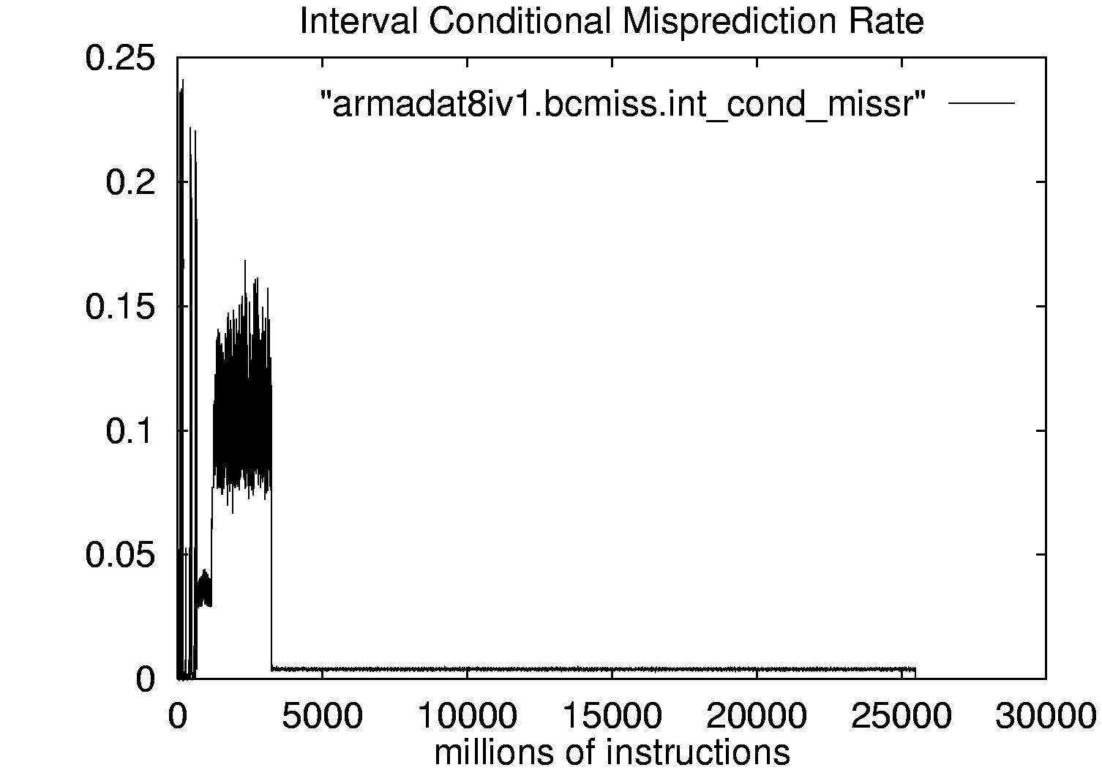

Fig. 1. Interval Conditional Misprediction Rate for armaest22e with armadat8iv1 as input

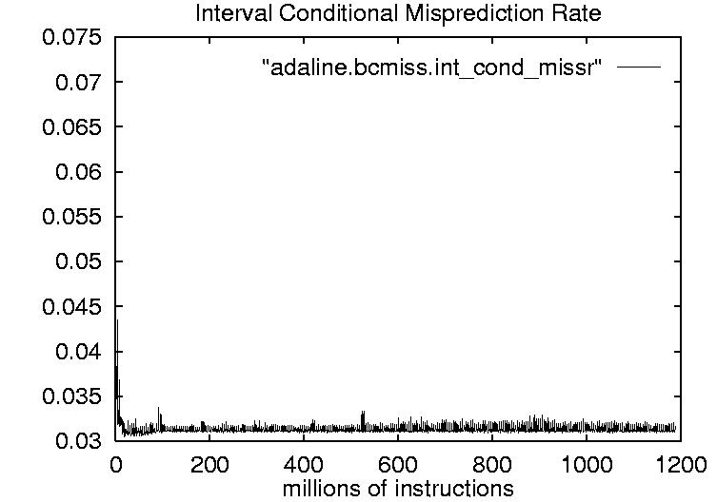
Fig. 2. Interval Conditional Misprediction Rate for Adaline
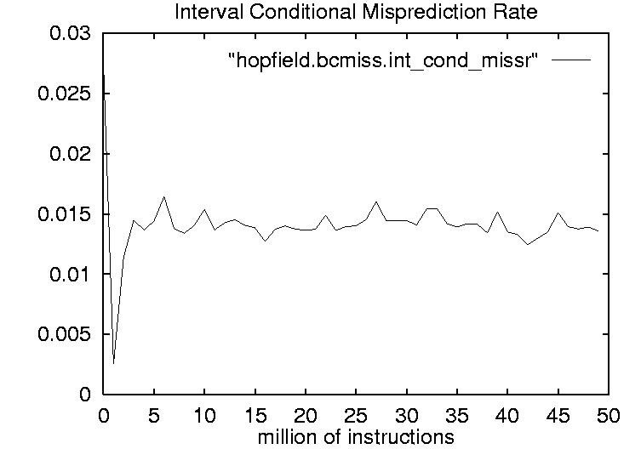
Fig. 3. Interval Conditional Misprediction Rate for Hopfield

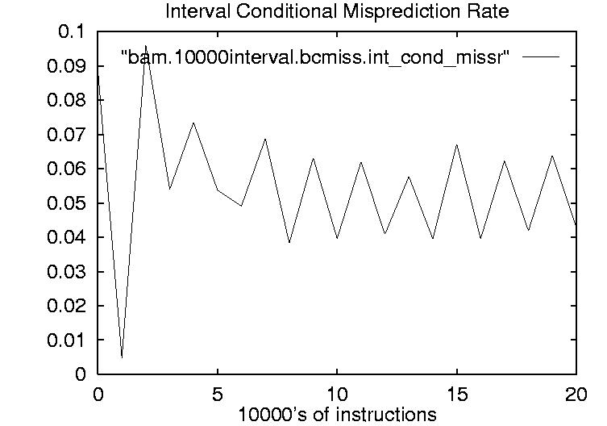
Fig. 4. Interval Conditional Misprediction Rate for BAM

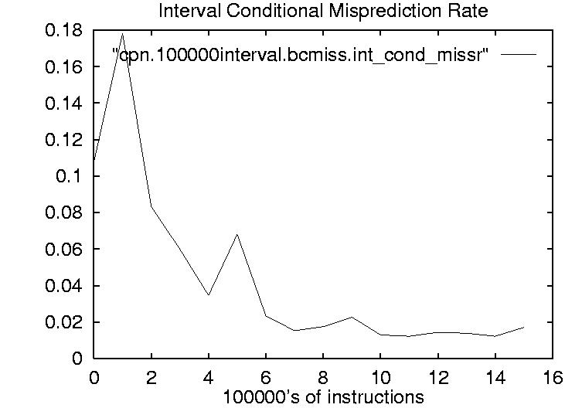
Fig. 5. Interval Conditional Misprediction Rate for CPN

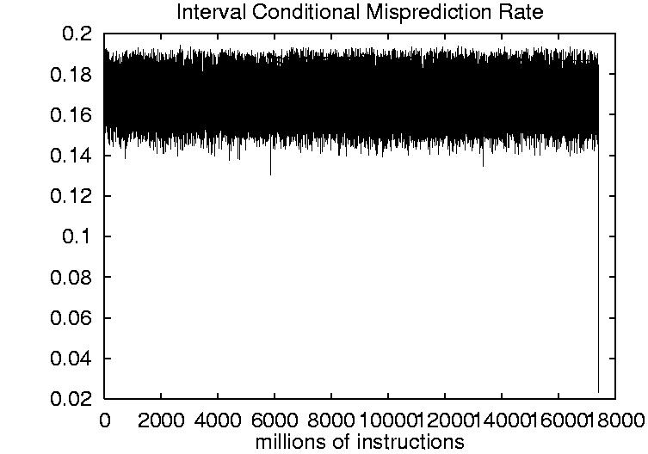
Fig. 6. Interval Conditional Misrediction Rate for SOM
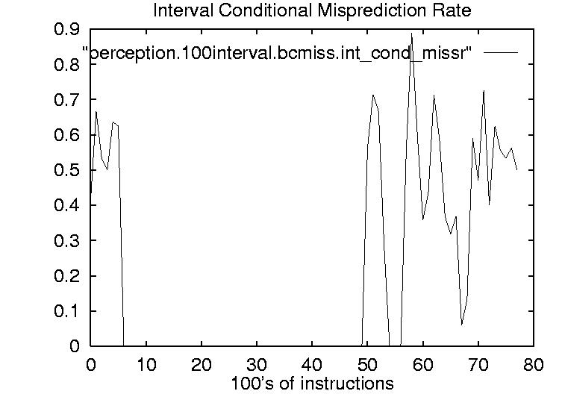

Fig. 7. Interval Conditional Misprediction Rate for Perceptron

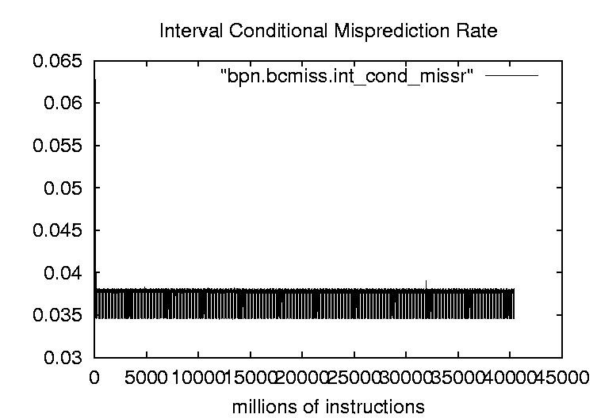

Fig. 8. Interval Conditional Misprediction Rate for BPN

