CS3102 Theory of Computation
Homework 1
Department of Computer Science, University of Virginia

Gabriel Robins

• This assignment is due before 11:59pm on Friday February 9, 2018; late submissions will not be accepted.
• This is an open-book, open notes, pledged homework assignment.
• You may work and brainstorm in groups, but verbatim copying of other people’s solutions is disallowed.
• Please carefully read the Cheating Policy on the CS3102 course syllabus.
• Please do not submit answers that you do not fully understand (we reserve the right to ask you
to explain any of your answers verbally in person, and we will definitely exercise this option).
• Solve as many of the problems as you can; please explain / prove all answers.
• Shorter explanations / proofs / algorithms are much preferable to longer ones.
• Clearly state the short answer / proof idea first, and then your complete answer / proof.
• Submit only the pages provided (use more sheets only if absolutely necessary).
• Please do not procrastinate / cram, which will not work well for you in this course.
• Please do not put us (and yourself) in an awkward position where you force us to say “we told you so”.

Please meet with the TAs often, ask them questions regularly, and attend the weekly problem-solving sessions.

Please submit your solutions through the online Collab system. In the rare case where that’s not possible, then please slip it under Professor Robins’ office door (406 Rice Hall) as a double-sided printed hardcopy.

Name:

Please pledge and sign here, certifying that you full complied with the Honor Code and the course Cheating Policy summarized on page 3 of the Course Syllabus:

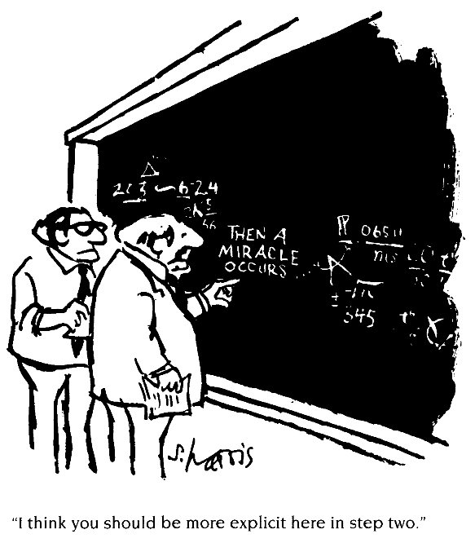

Problem 1: 20
Problem 2: 20
Problem 3: 20
Problem 4: 20
Problem 5: 40
Problem 6: 20
Problem 7: 20
Problem 8: 20
Problem 9: 20
Total: 200
Additional Instructions and Guidelines
Please solve the problems below and prove all your answers. Informal arguments are acceptable, but please make them precise / detailed / convincing enough so that they are rigorous. To review notation and definitions, please read the "Basic Concepts" summary posted on the class Web site and also read the initial chapter (Chapter 0) from the Sipser textbook.

Please directly edit this homework PDF file, insert your answers there, and submit your completed homework as a PDF attachment on the course Collab page. Please be sure to put your name on the first page and sign the pledge that you complied with the Honor Code as well as with the course Cheating Policy summarize on page 3 of the Course Syllabus. Please do not submit answers that you do not fully understand; we reserve the right to ask you to explain any of your answers verbally in person. Please uniquely name your submitted PDF file using your own name and your UVa computing ID, using the following file name format: LastName_FirstName_ComputingID_Homework_1.pdf (e.g. “Robins_Gabriel_gr3e_Homework_1.pdf”).

If you do not have a PDF-file editor, we recommend using for example either the PDF-Xchange Editor or Foxit. Both of these are free, and are powerful enough to complete your homework, including creating diagrams in your answers, if necessary. Many other free PDF editors can work also.

If for whatever reason you cannot find a suitable PDF editor that works for you, or you have trouble editing your homework PDF file, you may alternatively print out your homework, complete the homework by hand-writing your solutions on the hardcopy itself, and then submit your stapled marked-up hardcopy to Professor Gabriel Robins (by slipping it under his office door at 406 Rice Hall). If you use this option, your homework must be printed double-sided, you must not use any additional/extra pages, and your answers must fit in the pages/spaces provided. Please only use the hardcopy submission as a last resort, in the rare cases where the PDF editing & online Collab submission doesn't work for you. In other words, an online marked-up PDF Collab submission is much preferable than a hardcopy submission.

Please turn in your Homework 1 solutions before 11:59pm on Friday February 9, 2018. Late submissions will not be accepted (the online Collab system will simply refuse to accept late submissions after the deadline, so you literally will not even be able to turn it in late even if you try). So if you haven’t finished the assignment by the deadline, your best strategy is to just turn in the portion that you have finished by that time (rather than be late and not receive any credit for that assignment at all), and then going forward please make sure you are not late in turning in any future assignments.

Please note that if you plan to push the deadline and try to turn in an assignment a few minutes before the deadline, and something glitches in the system (e.g., network delays or server issues or other logistical problems), that too will be your responsibility since you chose to push the deadline and ignore our instructions to not procrastinate. In such a case you would have missed the opportunity to turn in the current assignment. So your best strategy in general is to turn in an assignment several days ahead of its deadline (these potential glitch-scenarios are already “baked into” the very generous due-date deadlines).

Please do not tell us after the fact that you didn’t realize all this, or that you decided to not plan accordingly, because then we will just remind you to re-read these instructions and advice here, and we will also remind you that not getting credit for an assignment is a very small price to pay for such an important life lesson in learning to not procrastinate and taking personal responsibility for your own decisions and actions. This policy is designed to help train people in good planning, avoiding procrastination, resisting the temptation to cheat, and taking personal responsibility for their decisions and actions like the adults that we all are. So whether this is obvious to you or not, these policies are actually designed for your own benefit and will help you become a more effective individual – our gift to you! ☺

Aside from turning in the assigned homeworks, you are expected to also work on the posted problem sets on a daily/weekly basis. Remember that most homework and exam questions will come from those longer posted problem sets (or will be variations thereof). So your best strategy is to solve as many problems as you can during the semester on a daily basis, meet regularly with the course TAs, and attend as many of the problem-solving sessions as possible (hopefully all of them). We estimate that to fully understand and master the material of this course typically requires an average effort of somewhere between at least six and ten hours per week, as well as regular meetings with the TAs and attendance of the weekly problem-solving sessions.

We also observed that historically, people who attend the weekly problem-solving sessions tend to perform more than a full letter grade better in the course, as well as less tempted to cheat, as compared with people who do not attend these weekly meetings. So if you only spend a couple of hours per week on this course, you are already seriously underestimating the amount of effort and practice required to learn this material, and we sincerely ask you to please stay on top of things, not procrastinate, and regularly practice solving lots of problems. Please do not put us (and yourself) in an awkward position where you force us to say “we told you so” (and “we even told you so in writing. Repeatedly.”)

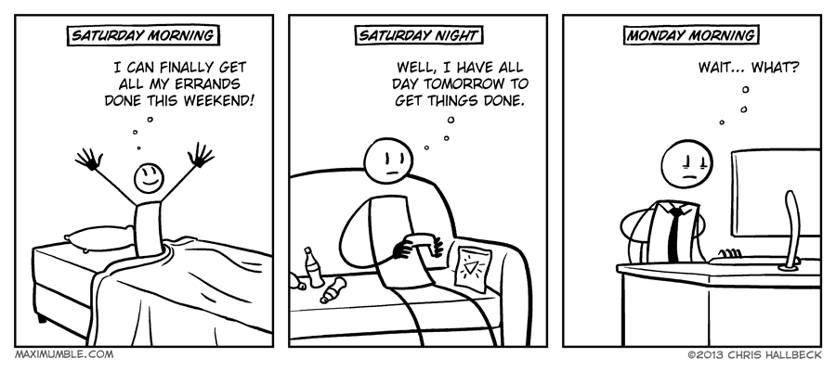
1. Powersets: Solve problem 0.5 on page 26 of [Sipser, Second Edition].

Short answer (formula in terms of c):

Proof:

2. Graph degrees: Solve problem 0.12 on page 27 of [Sipser, Second Edition].

Short answer (proof idea):

Proof:

3. True or false: a countable union of countable sets is countable.

Short answer (circle one): True False

Proof:

4. True or false: if a set T is countable, then the set of all finite subsets of T
namely{S | S ⊆ T, S finite} is also countable.

Short answer (circle one): True False

Proof:

5. What is the cardinality of each of the following sets ?
(i.e., finite, countably infinite, or uncountably infinite)

5a. The set of all possible Java programs

Short answer (circle one): Finite Countably infinite Uncountably infinite

Proof:

5b. The set of all finite strings over the alphabet {0,1,2}

Short answer (circle one): Finite Countably infinite Uncountably infinite

Proof:

5c. {Ø, N, Q, R}

Short answer (circle one): Finite Countably infinite Uncountably infinite

Proof:

5d. R - Q

Short answer (circle one): Finite Countably infinite Uncountably infinite

Proof:

6. Prove without using induction that n4 - 4n2 is divisible by 3 for all n≥0.

Short answer (proof idea):

Proof:

7. How many distinct Boolean functions with N input Boolean variables are there?
In other words, what is the cardinality |F_{N}| of the set F_{N} = {ƒ | ƒ:{0,1}N→{0,1}} ?

Short answer (formula in terms of N):

Proof:

8. Describe the significance, implications, and benefits of the four-quadrant “important vs. due-soon” time management decision strategy discussed in Randy Pausch’s Time Management lecture, and explain how this relates to procrastination, cramming, and increased effectiveness.

Response:

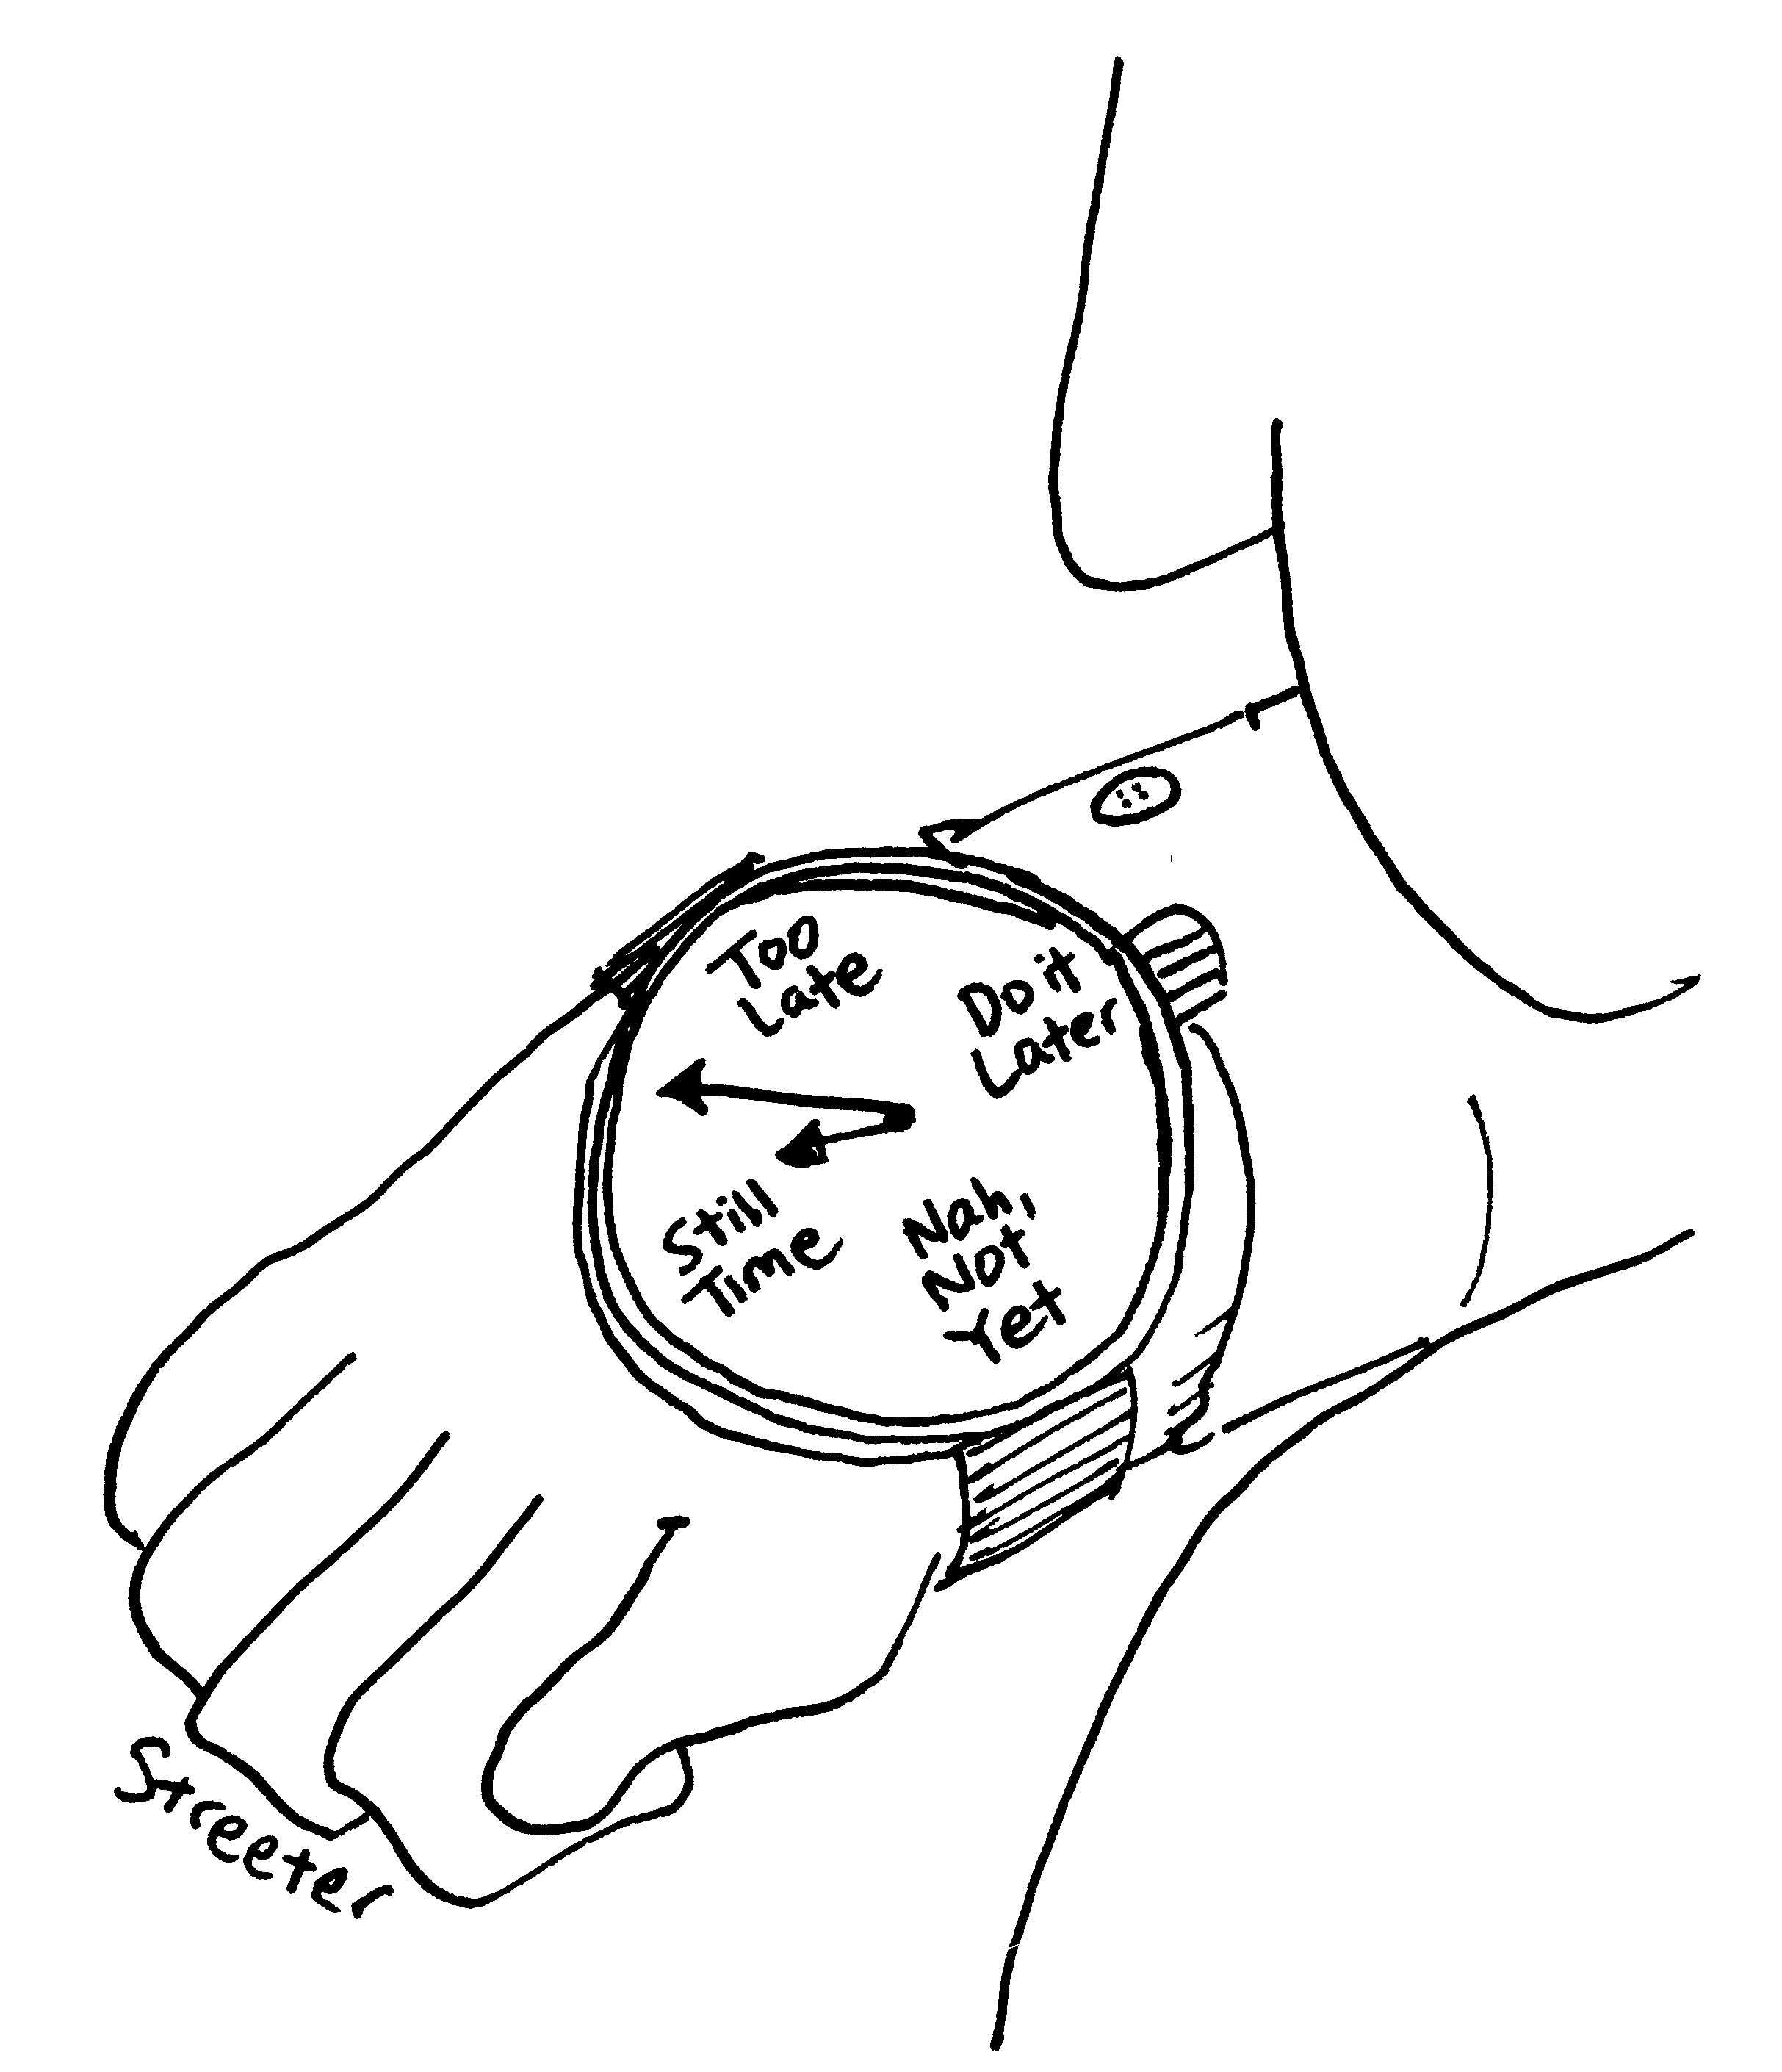
9. Carefully read the course Syllabus, and give your thoughts on the current cheating policy (page 3), including suggestions on how it can be further enhanced to discourage cheating behaviors. We will use your suggestions to further enhance the course logistics (even during this current semester).

Your thoughts and suggestions:



