CS3102 Theory of Computation
Homework 5
Department of Computer Science, University of Virginia

Gabriel Robins

• This assignment is due before 11:59pm on Sunday April 29, 2018; late submissions will not be accepted.
• This is an open-book, open notes, pledged homework assignment.
• You may work and brainstorm in groups, but verbatim copying of other people’s solutions is disallowed.
• Please carefully read the Cheating Policy on the CS3102 course syllabus.
• Please do not submit answers that you do not fully understand (we reserve the right to ask you
to explain any of your answers verbally in person, and we will definitely exercise this option).
• Solve as many of the problems as you can; please explain / prove all answers.
• Shorter explanations / proofs / algorithms are much preferable to longer ones.
• Clearly state the short answer / proof idea first, and then your complete answer / proof.
• Submit only the pages provided (use more sheets only if absolutely necessary).
• Please do not procrastinate / cram, which will not work well for you in this course.
• Please do not put us (and yourself) in an awkward position where you force us to say “we told you so”.

Please meet with the TAs often, ask them questions regularly, and attend the weekly problem-solving sessions.

Please submit your solutions through the online Collab system. In the very rare case where that’s not possible, then please Email your PDF to the course TAs (and CC Professor Robins).

Name: UVa Computing ID:

Please pledge and sign here, certifying that you full complied with the Honor Code and the course Cheating Policy summarized on page 3 of the Course Syllabus:

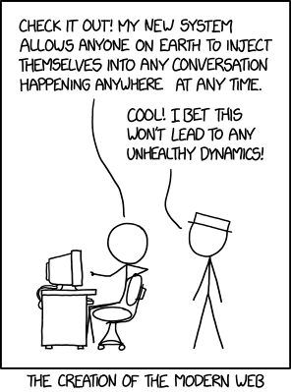
Problem 1: 20
Problem 2: 20
Problem 3: 20
Problem 4: 20
Problem 5: 20
Problem 6: 20
Problem 7: 20
Total: 140 _
EC Problem 8a: 20
EC Problem 8b: 20
EC Total: 40 _
Additional Instructions and Guidelines
Please solve the problems below and prove all your answers. Informal arguments are acceptable, but please make them precise / detailed / convincing enough so that they are rigorous. To review notation and definitions, please read the "Basic Concepts" summary posted on the class Web site and also finish reading Chapter 7 (entitled “Time Complexity”, pages 247-294) in the [Sipser, Second Edition] textbook.

Please directly edit this homework PDF file, insert your answers there, and submit your completed homework as a PDF attachment on the course Collab page. If you do not have a PDF-file editor, we recommend using for example either the PDF-Xchange Editor or Foxit. Both of these are free, and are powerful enough to complete your homework, including creating diagrams in your answers, if necessary. Many other free PDF editors can work also. If you prefer to edit the MS Word version of this file and then convert it into a PDF document, an MS Word version of this file is available as a link from the class Web site.

Please do not submit answers that you do not fully understand; we reserve the right to ask you to explain any of your answers verbally in person (and we have exercised this option in the past). Please put your name and computing ID on the first page, and sign the pledge that you complied with the UVa Honor Code as well as with the course Cheating Policy summarize on page 3 of the Course Syllabus.

Important: please uniquely name your submitted solutions PDF file using your name and your UVa computing ID, using the file name format: LastName_FirstName_ComputingID_Homework_5.pdf (e.g. “Robins_Gabriel_gr3e_Homework_5.pdf”).

If for any reason you cannot find a suitable PDF editor that works for you, or you have trouble editing your homework PDF file, you may edit the Microsoft Word version of the file (available on the class Web site), and then re-generate the PDF with your solutions included in it. Either way, you must use Collab to submit your PDF file (not a hardcopy). In the very rare case that Collab doesn’t work for you, please Email your PDF to the course TAs (and CC Professor Robins).

Please turn in your Homework 5 solutions into Collab before 11:59pm on Sunday April 29, 2018. Late submissions will not be accepted (the online Collab system will simply refuse to accept late submissions after the deadline, so you literally will not even be able to turn it in late even if you try). So if you haven’t finished the assignment by the deadline, your best strategy is to just turn in the portion that you have finished by that time (rather than be late and not receive any credit for that assignment at all), and then going forward please make sure you are not late in turning in any future assignments.

Please note that if against our advice you plan to push the deadline and try to turn in an assignment a few minutes before the deadline, and something glitches in the system (e.g., network delays or server issues or other logistical problems), that too will be your responsibility since you chose to push the deadline and ignore our instructions to not procrastinate. In such a case you would have missed the opportunity to turn in the current assignment. So your best strategy in general is to turn in an assignment several days ahead of its deadline (these potential glitch-scenarios are already “baked into” the very generous due-date deadlines).
Please do not tell us after the fact that you didn’t realize all this, or that you decided to not plan accordingly, because then we will just remind you to re-read these instructions and advice here, and we will also remind you that not getting credit for an assignment is a very small price to pay for such an important life lesson in learning to not procrastinate and taking personal responsibility for your own decisions and actions, and the resulting consequences. This policy is designed to help train people in good planning, avoiding procrastination, resisting the temptation to cheat, and taking personal responsibility for their decisions and actions like the adults that we all are. So whether this is obvious to you or not, these policies are actually designed for your own benefit and will help you become a more effective individual – our gift to you! ☺

Aside from turning in the assigned homeworks, you are expected to also work on the posted problem sets on a daily/weekly basis. Remember that most homework and exam questions in this course come from the posted problem sets (or will be minor variations thereof). So your best strategy is to solve as many problems as you can during the semester on a daily basis (not only the ones that are assigned on the Homeworks). You should also meet regularly with the course TAs, and attend as many of the problem-solving sessions as possible (hopefully all of them). We estimate that to fully understand and master the material of this course typically requires an average effort of somewhere between at least six and ten hours per week, as well as regular meetings with the TAs and attendance of the weekly problem-solving sessions.

We also observed that historically, people who attend the weekly problem-solving sessions tend to perform more than a full letter grade better in the course, as well as less tempted to cheat, as compared with people who do not attend these weekly meetings. So if you only spend a couple of hours per week on this course, you are already seriously underestimating the amount of effort and practice required to learn this material, and we sincerely ask you to please stay on top of things, not procrastinate, and regularly practice solving lots of problems. Please do not put us (and yourself) in an awkward position where you force us to say “we told you so” (and “we even told you so in writing. Repeatedly.”)

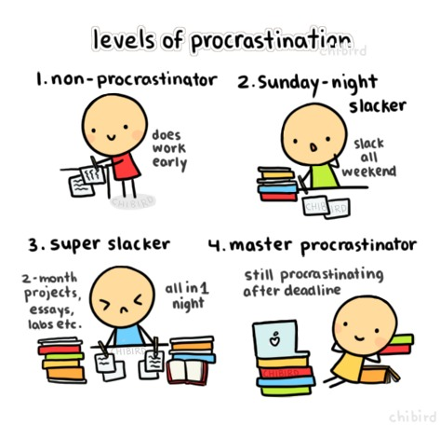
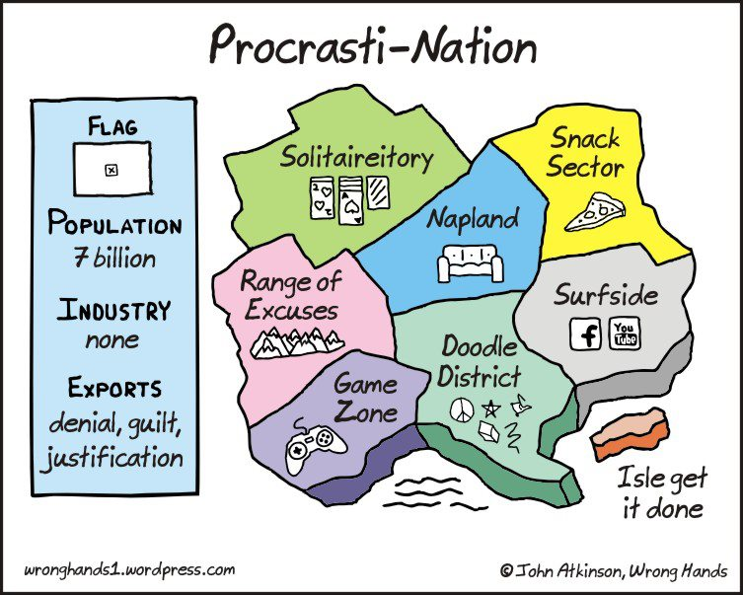

1. Let S = {R$Q | R and Q are both strings denoting arbitrary regular expressions over the same
fixed alphabet ∑, and L(R) ⊆ L(Q)}. True, false, or open question: the language S is decidable.

(This comes from problem 1 on Problem Set 6, and is also Problem 4.12 on page 183
of the [Sipser, Second Edition] textbook.)

Short answer (circle one): true false open

Proof idea (one short phrase):

Proof:

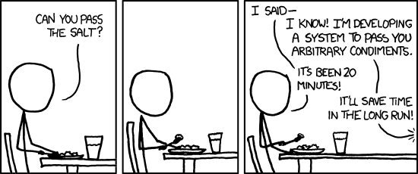
2. Let A and B be two disjoint languages (i.e. their intersection is empty). A language C is said to
separate languages A and B if A ⊆ C and B ⊆ ∑*- C. True, false, or open question: any two disjoint languages with Turing-recognizable complements are separable by some decidable language.

(This comes from problem 1 on Problem Set 6, and is also Problem 4.18 on page 184 of
the [Sipser, Second Edition] textbook.)

Short answer (circle one): true false open

Proof idea (one short phrase):

Proof:

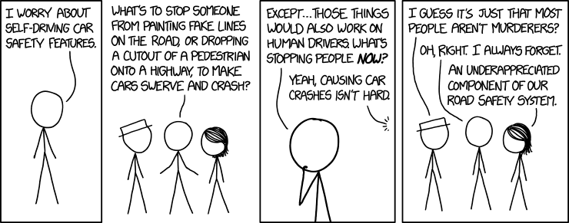
3. True, false, or open question: is P ∩ NP ∩ co-NP countably infinite?

(This comes from problem 9 on Problem set 7.)

Short answer (circle one): true false open

Proof idea (one short phrase):

Proof:

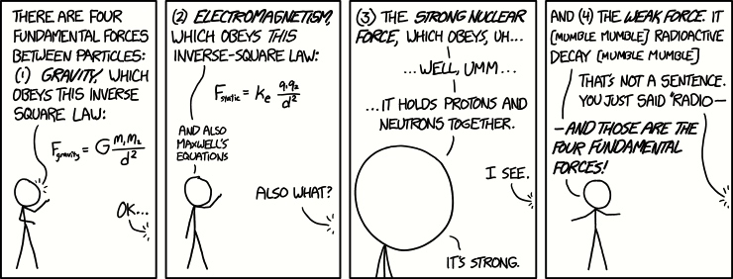
4. True, false, or open question: the set of incompressible strings contains no infinite recognizable subsets.

(This comes from problem 1 on Problem set 7, and is also Problem 6.24 on page 243 of
the [Sipser, Second Edition] textbook.)

Short answer (circle one): true false open

Proof idea (one short phrase):

Proof:

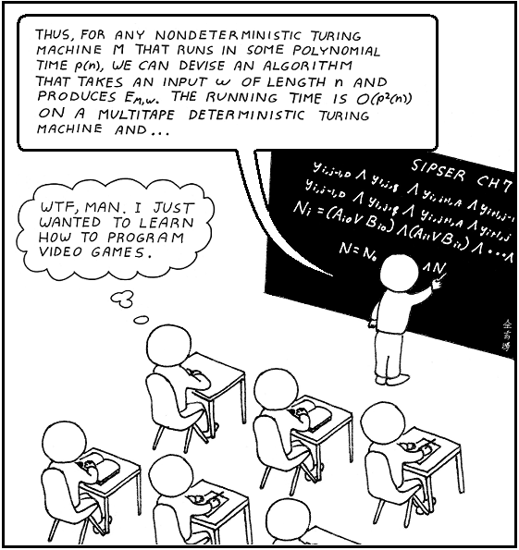
5. Two space aliens walk into your home, both claiming to be oracles for the Boolean Satisfiability
(SAT) decision problem. They both always give a yes/no answer in constant time for any SAT
instance, and are each self-consistent (i.e. each always gives the same answer for the same instance).
However, one is a true oracle and the other is a shameless impostor, and you have a large SAT
instance F upon which they disagree (i.e. one claims that this SAT instance F satisfiable and the other
one claims that F is not satisfiable). Prove whether the following is true, false, or an open question:
it is possible to expose the impostor within time polynomial in the size of that SAT instance F.

(This is problem 15 on Problem Set 7.)

Short answer (circle one): true false open

Proof idea (one short phrase):

Proof (or algorithm):

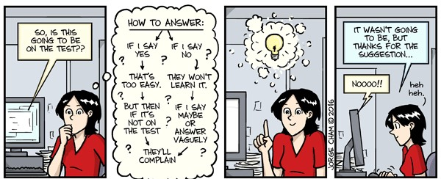
6. True, false, or open question: most Boolean functions on N inputs require an exponential
(as a function of N) number of 2-input Boolean gates to implement.

(This is problem 18 on Problem Set 7.)

Short answer (circle one): true false open

Proof idea (one short phrase):

Proof:

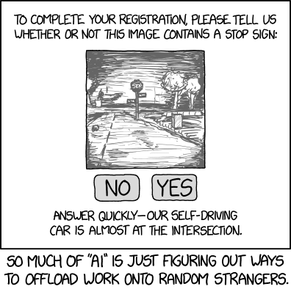
7. True, false, or open question: 2-SAT is solvable in polynomial time.

(This problem was discussed in class, and was also given for extra-credit.)

Short answer (circle one): true false open

Proof idea (one short phrase):

Proof (or algorithm):

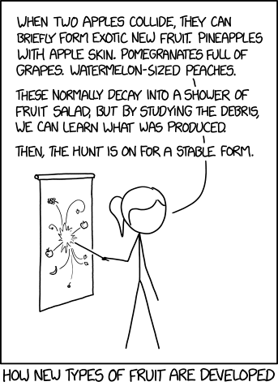
8. “Second Chances” extra-credit:

Pick two problems that you may not have correctly solved (or left blank) on the last homework (i.e. Homework #4), and solve them again here. If you already solved everything correctly on the last homework, you may still pick a couple of problems that you may not have correctly solved on any of the previous homeworks, and solve them here.

8a) Extra-credit: state here the previous-homwork(s) problem A that you are (re-)solving below:

Solution:

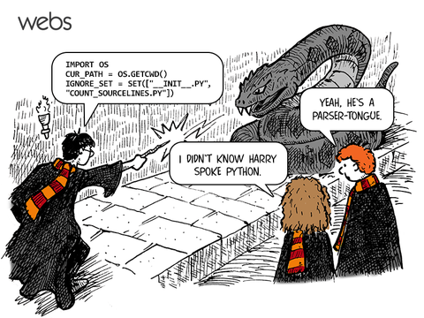
8b) Extra-credit: state here the previous-homwork(s) problem B that you are (re-)solving below:

Solution:


