Monitoring Sleep with WISP Tags

Enamul Hoque, Robert F. Dickerson, and John A. Stankovic

Center for Wireless Health, Department of Computer Science, University of Virginia

Abstract
This chapter presents a sleep monitoring system based on WISP tags. We show that our system accurately infers fine-grained body positions from accelerometer data collected from the WISP tags attached to the sides of a bed. Movements, duration, and bed entrances and exits are also detected by the system. We present the results of an empirical study from 10 subjects on three different mattresses in controlled experiments to show the accuracy of our inference algorithms. We also evaluate the accuracy of the movement detection and body position inference for six nights on one subject, and compare these results with two baseline systems. Preliminary data investigating the correlation between sleep stages from the Zeo and movement is also presented.

INTRODUCTION
RFID is an important technology that has already experienced great success in several different application areas. With the advent of adding sensing to RFIDs, as found in WISP tags, many new applications are possible. One promising area for WISP applicability is in smart homes. The tags may be used for applications designed to save energy, automate homes, or to remotely monitor health. For monitoring many medical conditions, being able to assess the duration and quality of sleep plays an important role.

Because of its importance, many sleep-monitoring systems have been developed. These systems attempt to recognize sleeping disorders by providing healthcare providers with quantitative data about irregularity in sleeping periods and durations or the amount of agitation and restlessness experienced during the night. These solutions vary in cost, comfort, and accuracy. In this chapter, we describe the main categories and characteristics of current solutions and then detail a new approach based on WISP tags.
The new system does not require any specific action from patients. In this system, we attach several WISP tags to the bed mattress and collect accelerometer data. Using the data we infer body positions, movements, and entries and exits from the bed. We compare the performance of our system with several baseline systems including using pressure pads, video, a popular iPhone based sleep monitoring application, and the Zeo.

Background
To date, while there are many sleep monitoring systems there are very few low-cost, unobtrusive (comfortable) solutions. In this section we outline the major categories of solutions and describe their characteristics and limitations.

Physiological signals are regarded as the most accurate means to differentiate between awake and sleep phases such as light, REM, and deep sleep. The electroencephalogram (EEG) measures the frequency of brain waves to discern sleep and wake stages (Carskadon 1989). The electrooculogram (EOG) and electromyogram (EMG) are also standard technologies for sleep monitoring. The electrocardiogram (ECG) can be used to measure the heart rate, which is well known to decrease upon sleep onset. Some studies show that heart rate varies over different sleep stages (Redmond 2006, Shinar 2006) by use respiratory-derived features together with ECG-derived features for classifying different sleep stages automatically. These techniques have major limitations- they are costly since they require trained professionals in clinical environments to administer them and invasive since these techniques require equipment to be attached to patients, limiting their movement and causing discomfort. These physiological signals do not support monitoring body positions during sleep.

Temperature regulation in a body can also be used to monitor sleep quality. Skin temperature increases during sleep onset and decreases during wakeup (Krauchi 2004). But these temperature variations can only be measured under controlled laboratory conditions. (Yang 2006) uses an infrared triangulation distance sensor to detect movements of different body parts without attaching any device to the body. But it does not provide any information about body position.

To overcome the limitations of the above techniques, there are many systems that enable sleep monitoring in home environments. Actigraphy (Sadeh 2002) is a commonly used technique for sleep monitoring that uses a watch-like accelerometer based device attached typically to the wrist. The device monitors activities and later labels periods of low activity as sleep. There are many commercial products like the Philips Actiwatch that are designed based on actigraphy. The Zeo is another commercial product for sleep monitoring in home environments. It is a headband that users need to wear each night so that it can detect sleep patterns through the electrical signals naturally produced by the brain. There is also an associated display that shows a person’s sleep pattern for the previous night. These products are expensive and users need to wear the device.

Another method used for sleep monitoring is to instrument a mattress pad with sensors and passively infer body movements and sleep quality. The Bed Alarm Sensor Pad is such a commercial bed pressure-sensing pad that monitors change in body pressure on the pad to detect movements. In (Van der Loos 2001) the authors use pressure and temperature sensors laid out in a grid pattern in the mattress to determine quality of sleep. NAPS (Mack 2003, Mack 2006) is a low-cost physiological sensor-suite that can passively acquire important physiological and environmental characteristics. The NAPS suite allows subjects to simply lie on a mattress pad, embedded with vibration sensors, to obtain multidimensional data (e.g., body temperature, heart rate, respiration rate, positional mapping and movement). One might also use tiny sensor motes with accelerometers in place of vibration sensors. The main advantage of all these solutions is that users do not need to wear any device. But, in some cases batteries are needed and it may also be uncomfortable to sleep on a pad and thus, they can affect sleep quality. For patients with incontinence there is also a problem with keeping the pads clean. Also, pressure pads can only detect body movements and correlate them to sleep quality. In our WISP based solution, we can add additional sensors in the WISP tags to monitor other environmental parameters (e.g., temperature, light) that can be useful in analyzing the effect of external environment on sleep quality.

Audio and video signals can also be used to determine sleep quality. In (Peng 2006) a combination of heart rate, audio and video sensors is used to infer a sleep-awake condition. But such systems raise privacy concerns among the users.

SleepCycle is a popular iPhone based application that uses the accelerometer in the iPhone to monitor body movements and determine which sleep phase the user is in. The user just needs to put the iPhone in a suitable place on the bed. However, such iPhone based solutions can only monitor changes in accelerometer values in a certain place on the bed. In our experiments, we show that using WISP tags in three different places in the bed improves the accuracy of detecting body movements compared to using one/two WISP tags. Three WISP tags also enable us to monitor fine-grained body position. Moreover, the iPhone can accidentally fall off the bed and it needs to be connected to the charger for the whole night.

In summary, the advantages of our WISP-based sleep monitoring system are that users do not need to wear any device, they do not need to sleep on any mattress pads instrumented with sensors, no batteries are needed, the system is wireless, and it avoids privacy violations of video solutions.

WISP BASED SLEEP MONITORING SYSTEM

The Design

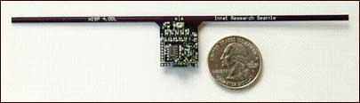

Figure 1 WISP Tag

The sensing elements in our system are WISP tags shown in Figure 1. The device's antenna and power harvesting circuitry enable off the shelf EPC “Gen 2” RFID readers, shown in Figure 2 to power and read from it. To a RFID reader, a WISP appears as a normal RFID tag, but inside the WISP, the harvested energy is operating a 16-bit fully programmable ultra low-power microcontroller. The microcontroller can sample a variety of sensing devices including 3-dimensional accelerometers, lights, and temperature sensors. In our system, we only use 3D accelerometer readings. The WISP tags report these readings by encoding them as part of their identifiers that are read by a RFID reader.

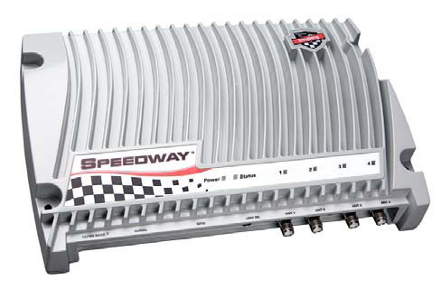

Figure 2 Speedway Reader

We attach three WISP tags along the edge of the mattress. As an example of the accelerometer readings, the y-axis reading for Tag 1 is shown in Figure 3.Such simple information (from all three tags and all three dimensions) is used to differentiate between when the bed is empty, someone is lying on it, or someone is just sitting on the bed watching television or reading. When the bed is empty, the y-axis accelerometer of the tag is aligned perpendicular with respect to gravity, but when someone lays on the bed, because of the impact of the body on the mattress, the orientation changes. These orientations are different from the one when someone is just sitting on the bed.

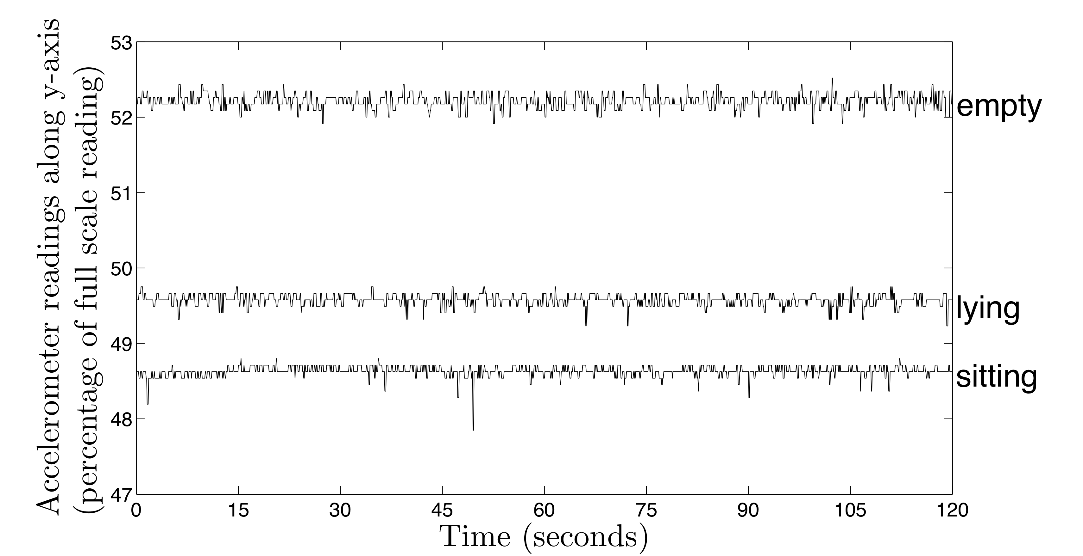

Figure 3 Accelerometer Reading Variation for Empty/Lying/Sitting

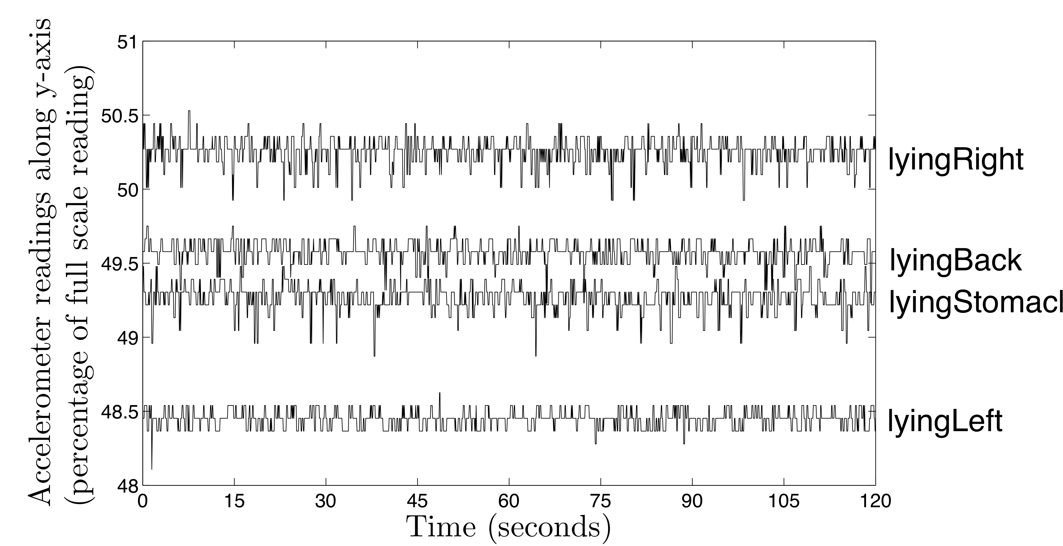

Figure 4 - Accelerometer Reading Variation for Different Lying Positions

Using the accelerometer readings, we distinguish four positions: lying on the back, stomach, left, or right sides (shown in Figure 4). In Figures 3 and 4 as an example, we show the accelerometer readings along the y-axis. Note that the readings along the z-axis(which is parallel to gravity) show similar variation. The readings along the x-axis do not show too much variation, but if we combine them with the readings along the y and z-axes, together they accurately differentiate among the four positions. The evaluation sections demonstrate the accuracy of this technique.

We are also interested in the amount of movement to detect restlessness and agitation. Each time someone moves on the bed, the accelerometer readings change rapidly. Using the change in these readings we detect each movement. The system monitors how many times a person tosses and turns during the course of the night and how many times the person leaves the bed. If someone is lying on the bed and does not move for a significant amount of time, then we assume the person is asleep. Frequency of movements is also different for different sleep stages and thus can be related to which sleep stage a person is currently in (Giganti 2008). Transitions between different sleep stages also correspond to change in frequency of body movements. Thus, based on a summary of movements made during each night, doctors can infer duration, quality of sleep and irregular sleeping patterns.

Evaluation – controlled experiments

Our evaluation of using WISP for sleep monitoring consists of controlled experiments for body position and for movement as well as real overnight experiments. Note that some of these results and the associated discussion were previously reported in (Hoque 2010).

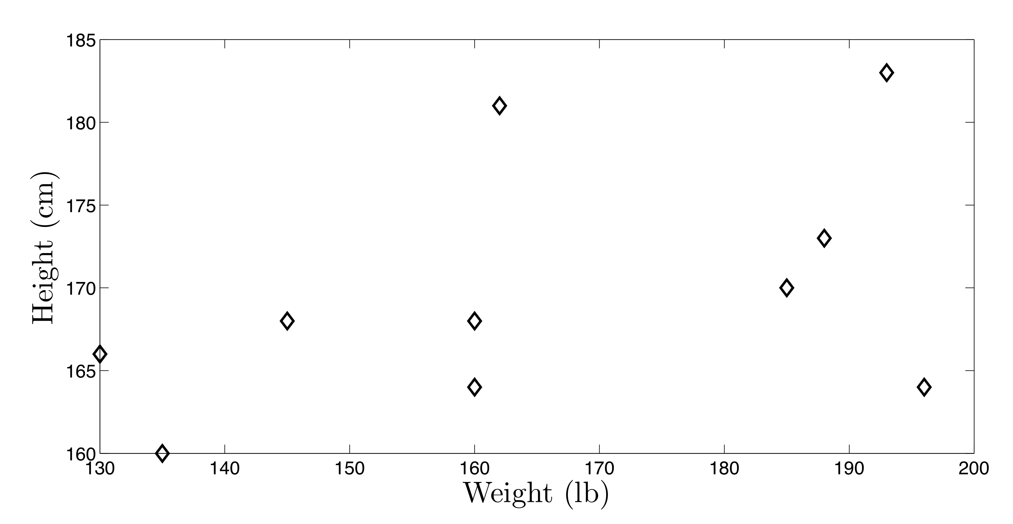

Figure 5 - Heights and Weights of the Subjects

For our controlled experiments, 10 graduate students volunteered as subjects. The subject population was diverse in both height and weight (shown in Figure 5). All participants were volunteers, and were informed of the experimental procedures and the study's goals prior to participation. We conducted our experiments in three different beds to consider how different mattresses affect the measurements. Five subjects were evaluated on a twin-size bed in our University's medical testbed called Alarmnet (Wood 2008). Five other subjects participated in each of the other two beds that were in a graduate student's apartment. All three of them were twin mattresses. So, for each bed, five subjects participated in the experiments. For two of the three beds the participating subjects were the same.

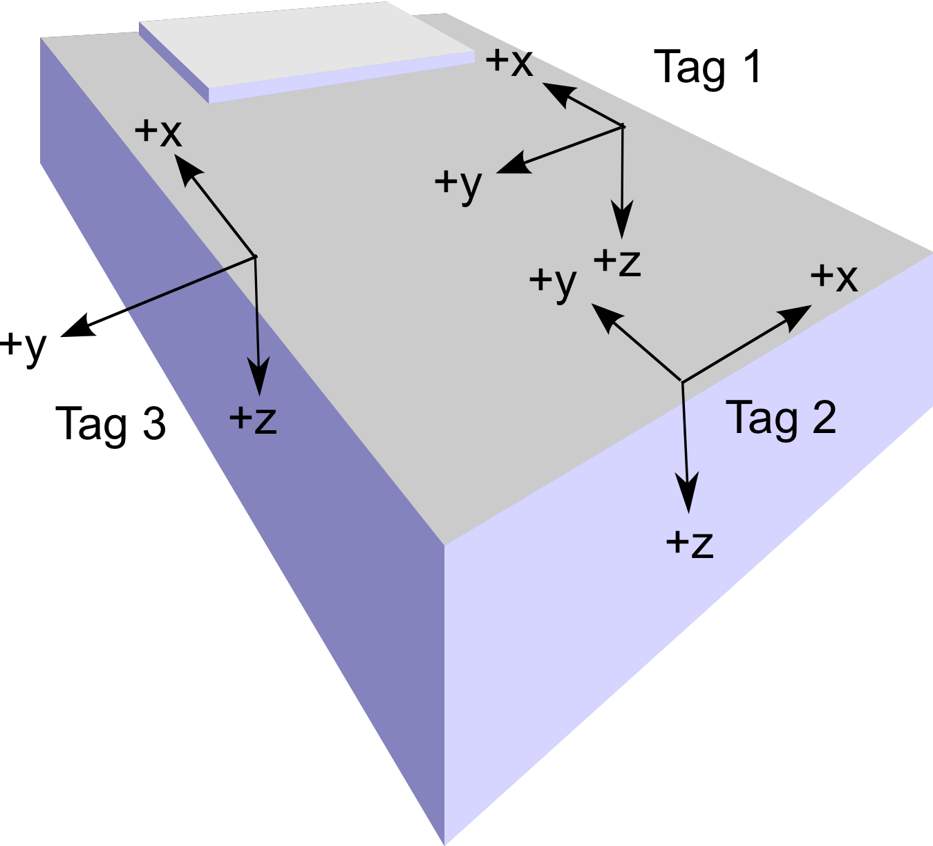

Figure 6 – Experimental Setup for the Bed

For each experiment, we attached 3 WISP tags to the mattress of a bed. Figure 6 shows such a bed along with the positions of the tags. We placed the tags in such a way that when someone lies on the bed, there is one tag on each side of his body and one tag near the legs. We used two antennas for reading from the tags. The reader sends 10 read requests per second. The read rate from each of the tag was 4-7 reads per second during all our experiments. If we use one antenna, then read rate of one or more tag falls much lower. One disadvantage of using the WISP tags is that they need to be placed within 1-2 meters of the antenna of the reader. To meet the read-range requirement and to keep the equipment away from obstructing a resident's movement, we placed the antennas below the bed. The antennas were wired to the reader that was connected with the laptop.

Note that we also investigated the use of a fourth tag near the head. However, this tag did not improve the accuracy and so we eliminated it.

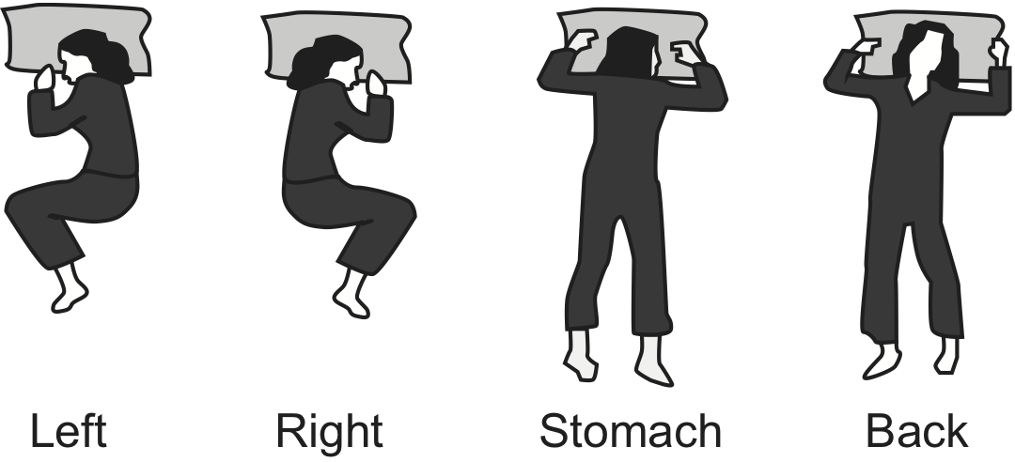

Figure 7 - Body Positions while Lying on the Bed

Each subject lay on the bed in the following four positions: on the back, on the stomach, on the left side and on the right side. These four positions are shown in Figure 7. Each subject also sat on the bed with his or her back on the wall and face towards the camera. This position resembles the way someone lies when watching television or reading a book while sitting in bed. For each position, we recorded data for two minutes. For each WISP tag, we obtained the acceleration along the x, y and z-axes. From the readings of all three tags, we get a 9-tuple. Note that, all three tags do not report their acceleration values synchronously. We combine the readings from the three tags within each second and construct each possible 9-tuple. We associate all the 9-tuples collected during these two minutes to that particular body position. We also recorded the readings from the tags when the bed was empty. We use the collected data to train our system.

After the training phase, the subject repeats the tasks again and we record data for 30 seconds for each position. Our system then classifies the new data based on previous training. For training and classification, we use the open source software “Orange Canvas” (Demsar 2004) which supports a number of classifiers. We decided to use the Naive Bayesian Classifier. Note that for each subject, first we train our system based on the subject's training data and then classify his or her remaining data.

Controlled Experiments - Body Position

For each subject, we classify the collected data under three different settings. In the first setting, we test whether it is possible to differentiate between the bed being empty and someone lying on it (in any position). So we label all data collected during a subject lying on the bed in four different positions as lying. We do not include the data when the subject was sitting on the bed. In the second setting, we include the data for sitting and test whether it is possible to differentiate among the bed being empty, or someone lying on it (in any position), or someone sitting on it. In the last setting, we test whether it is possible to differentiate among all six cases: empty, lying on back, lying on stomach, lying on back, lying on left side, lying on right side and sitting. We name the above three cases as “set1”, “set2” and “set3”.

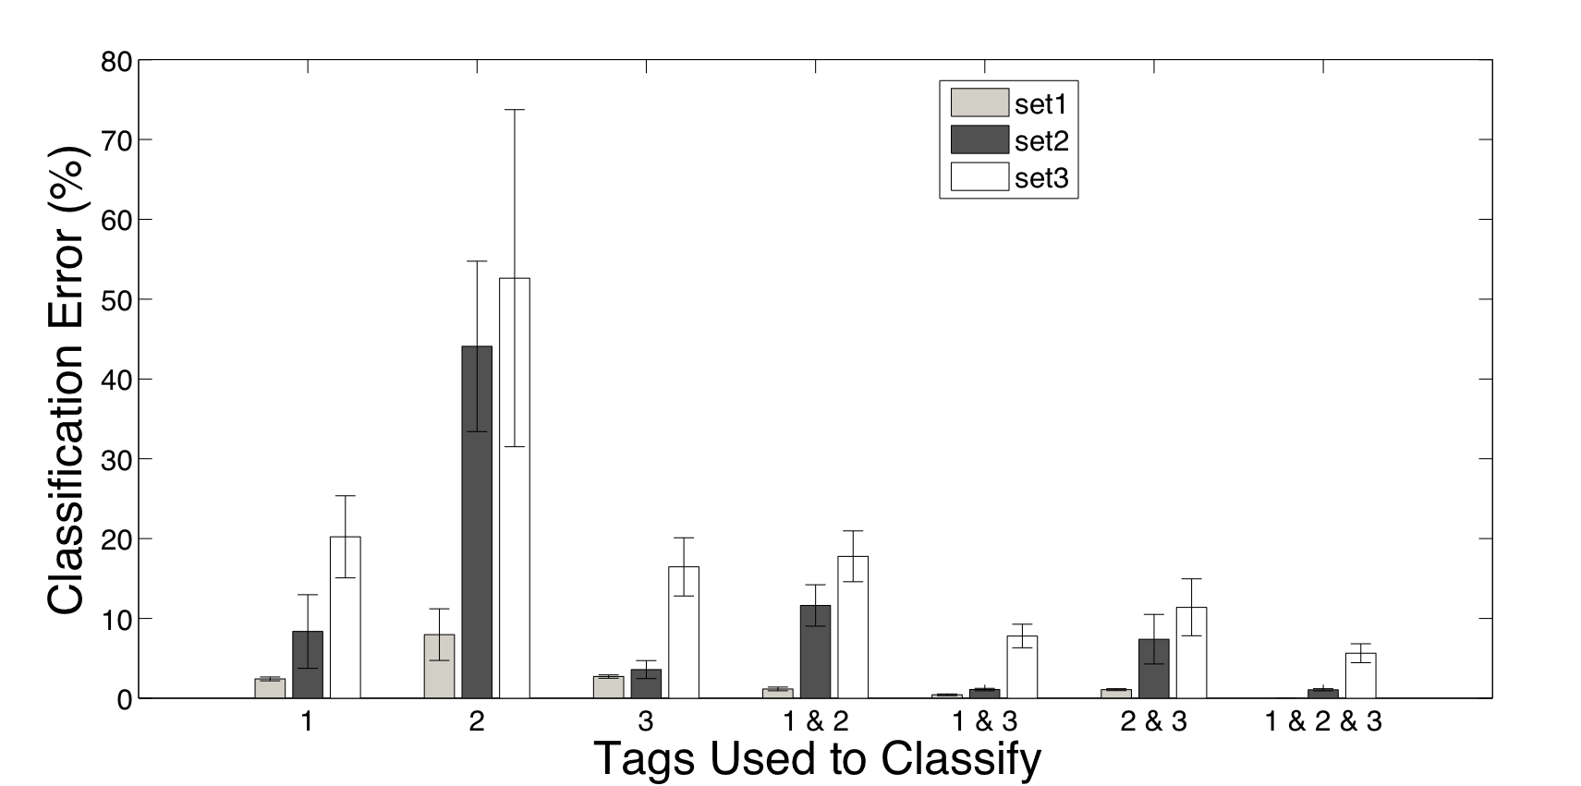

Figure 8 - Average Classification Error for five Subjects for One of the Beds

For each setting, first we train and classify based on the data collected from one tag only (tag no. 1, 2 or 3) of Figure 6 Then we use data from a combination of two of the three tags. Finally, we use data from all three tags. Our goal is to test how increasing the number of tags helps in reducing classification error. The results of our experiments on one of the three beds are summarized in Figure 8. Five of the 10 subjects participated in the experiments on this bed. For each case, the y-axis shows the average of percentage classification errors for all five subjects. The error bars represent the standard deviations of the errors for each experiment.

As we see from Figure 8, if we increase the number of tags, the classification error decreases. When we use data from only one tag, the performance of tag 2 is the worst. This is expected, because it is placed near the leg, and so it fails to capture enough of the variation of body impact on the middle portion of the mattress for different positions. When we use data from any two of the three tags, we see that the combination of tags 1 and 3 performs best. This is because both of them are placed in the middle parts of the two opposite edges of the mattress. When we use data from all three tags, the error for “set1” becomes almost zero. For “set2” and “set3”, average percentage errors are 1.06% and 5.64%, respectively. For the other two mattresses, we also observe similar trends, i.e., increasing the number of tags increases classification accuracy.

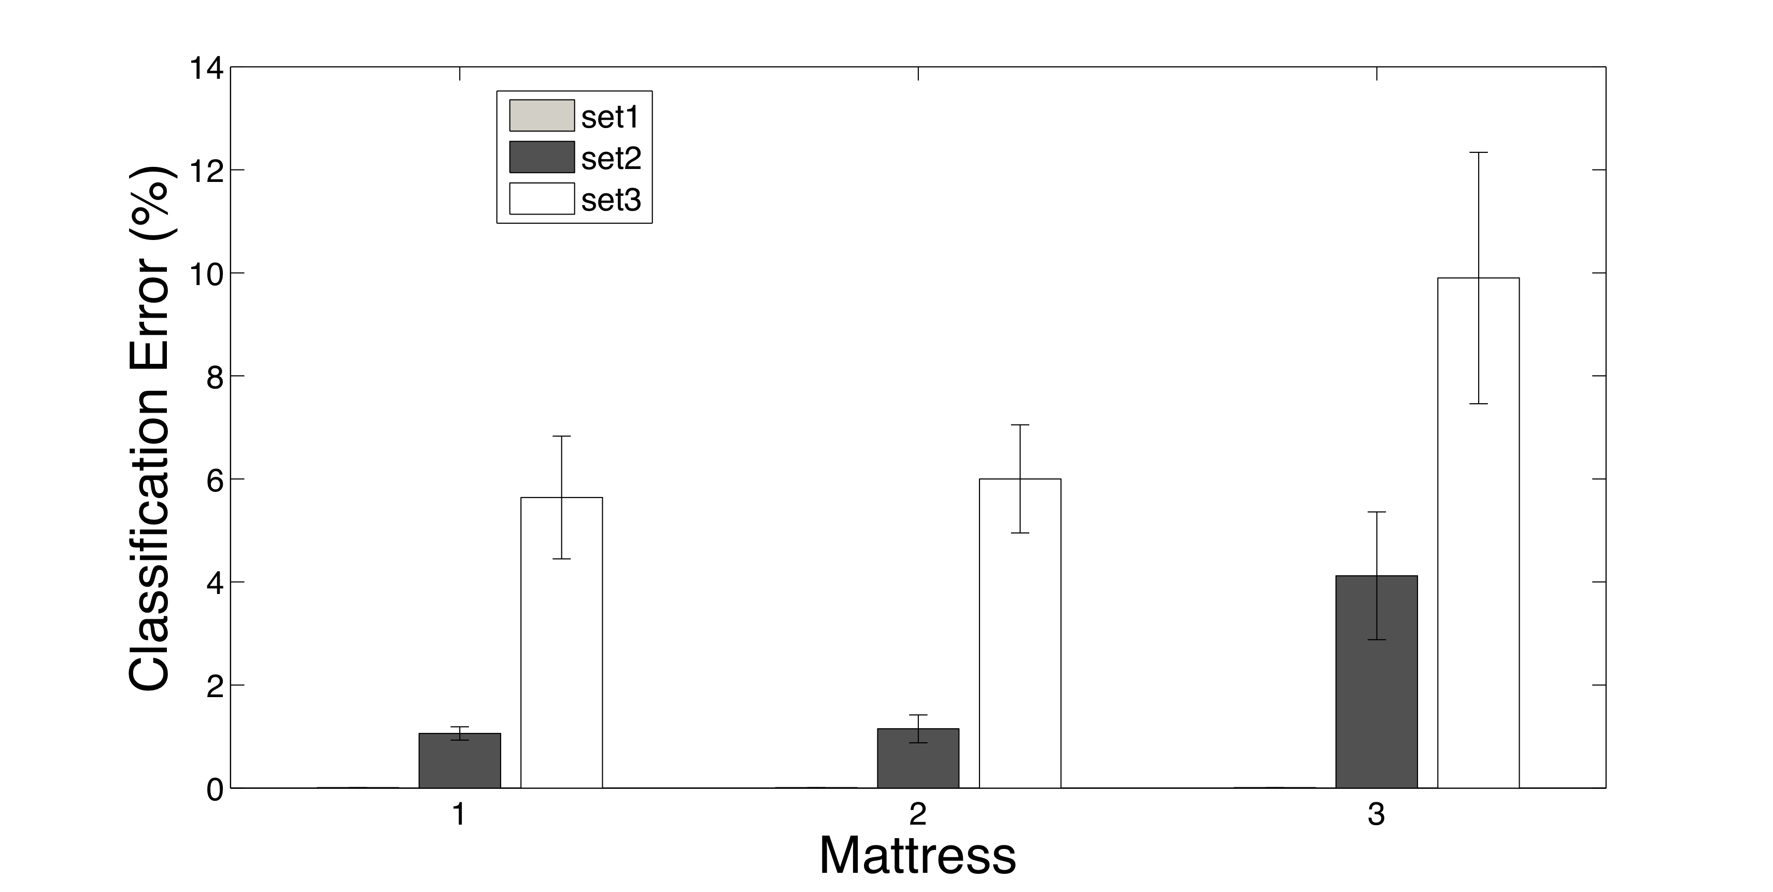

Figure 9 - Average Classification Error for All Mattresses

We also check how classification error varies over different mattresses. Figure 9 shows average classification error for all mattresses. Here we calculate the average over the classification errors for all subjects that participated in the experiments on a particular bed. As we see from the figure, classification error for “set1” is almost zero for all mattresses. But for the other two sets, classification error is greater for mattress 3 than the other two mattresses. This mattress is the one that is in our university testbed. The testbed quality is different than the other two. It is hard and inflexible. So, the impact of the body weight does not change the orientation of the WISP tags immediately. As mentioned earlier, we classify the body positions for 30 seconds of data for each subject. Later we used the data from the last 20 seconds and the classification error went down significantly and was approximately same as the other two mattresses. So for such mattresses, we need to classify the body position after the body settles in to a new position. One implication of these results is that we could build a new mattress with the correct flexibility and embedded WISP tags that is especially targeted for those wanting or needing sleep monitoring.

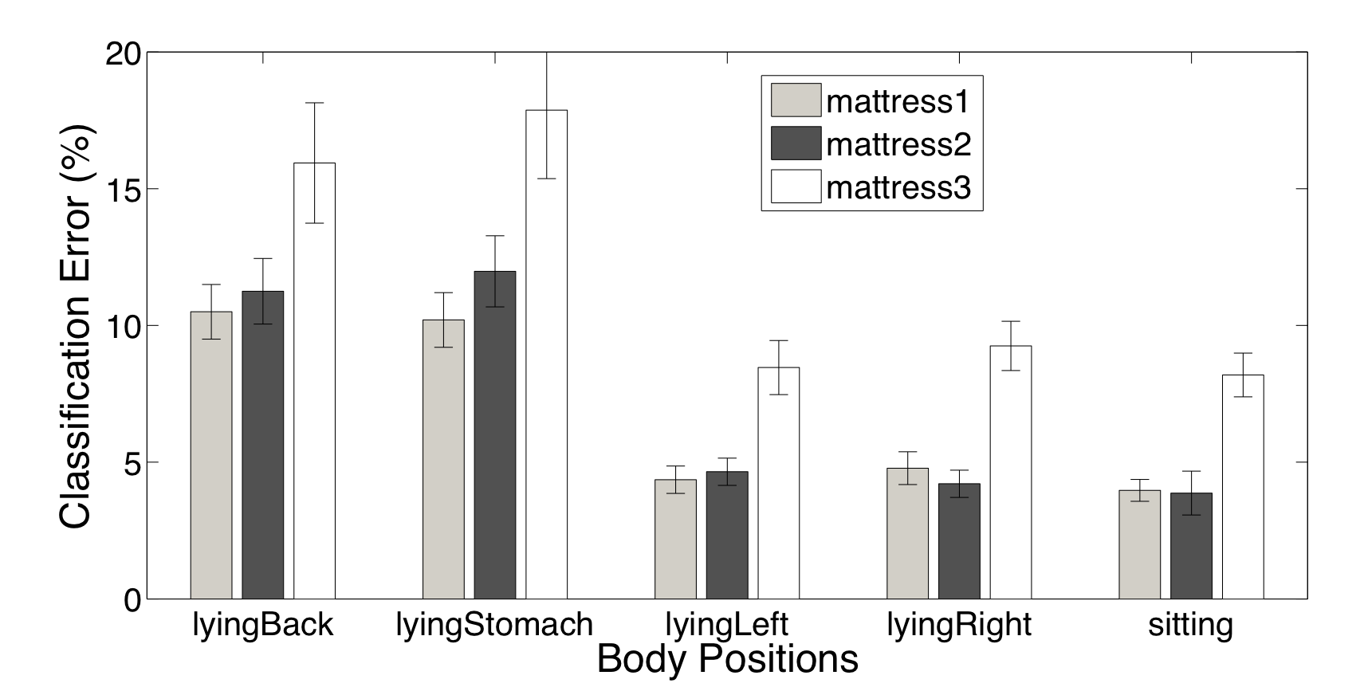
Figure 10 - Average Classification Error for Different Body Positions for All Mattresses

Now, we analyze what body positions are misclassified most. Here, we consider misclassifications for “set3” only. For every mattress, the case when the bed is empty is classified correctly. For the other positions, the average of misclassifications for each mattress is shown in Figure 10. Here, we see that classification error is most prominent for the two body positions where a subject lies on back and on stomach. The reason is that sometimes one of these is classified as the other. For both these positions, the impact of body weight on the mattress remains almost same. For the other three positions, the classification error remains less than 10% for each mattress.

Note that, for these controlled experiments, the training period is only two minutes for each body position. For practical use, we need to train the system for longer periods. During our realistic overnight experiments, we train our system for several nights (about seven hours per night) and then run the system. The results are much better and are shown in the later section on realistic overnight experiments.

Controlled Experiments - Movement Detection

As we see from the earlier Figures 3 and 4, when a subject lies on the bed in a particular position or when the bed remains empty, the accelerometer values returned by the WISP tags remain within a noise level of a particular value. This is true for acceleration values along each of the three axes. To find the maximum deviation in the readings, we calculate the derivative of all the readings when a subject remained in a particular position. The derivatives show that if the subjects remain in a particular position or if the bed is empty, the deviation remains in the interval [+a, -b]. The values of a and b vary for different tags, axes, and mattresses, but remain same for different subjects. We calculate these values from the data collected during the controlled experiments of the previous section.

If the subject moves to a new position or makes significant movements while remaining in the same body position, the derivative of the accelerations of all three tags along both y-axis and z-axis become higher than the corresponding +a or lower than the corresponding -b. So during the movements, the derivatives of y and z acceleration values cross the threshold values (+a and -b) several times. Figure 11 shows y-axis accelerometer readings during such a move. Here the values of both a and b are 1.

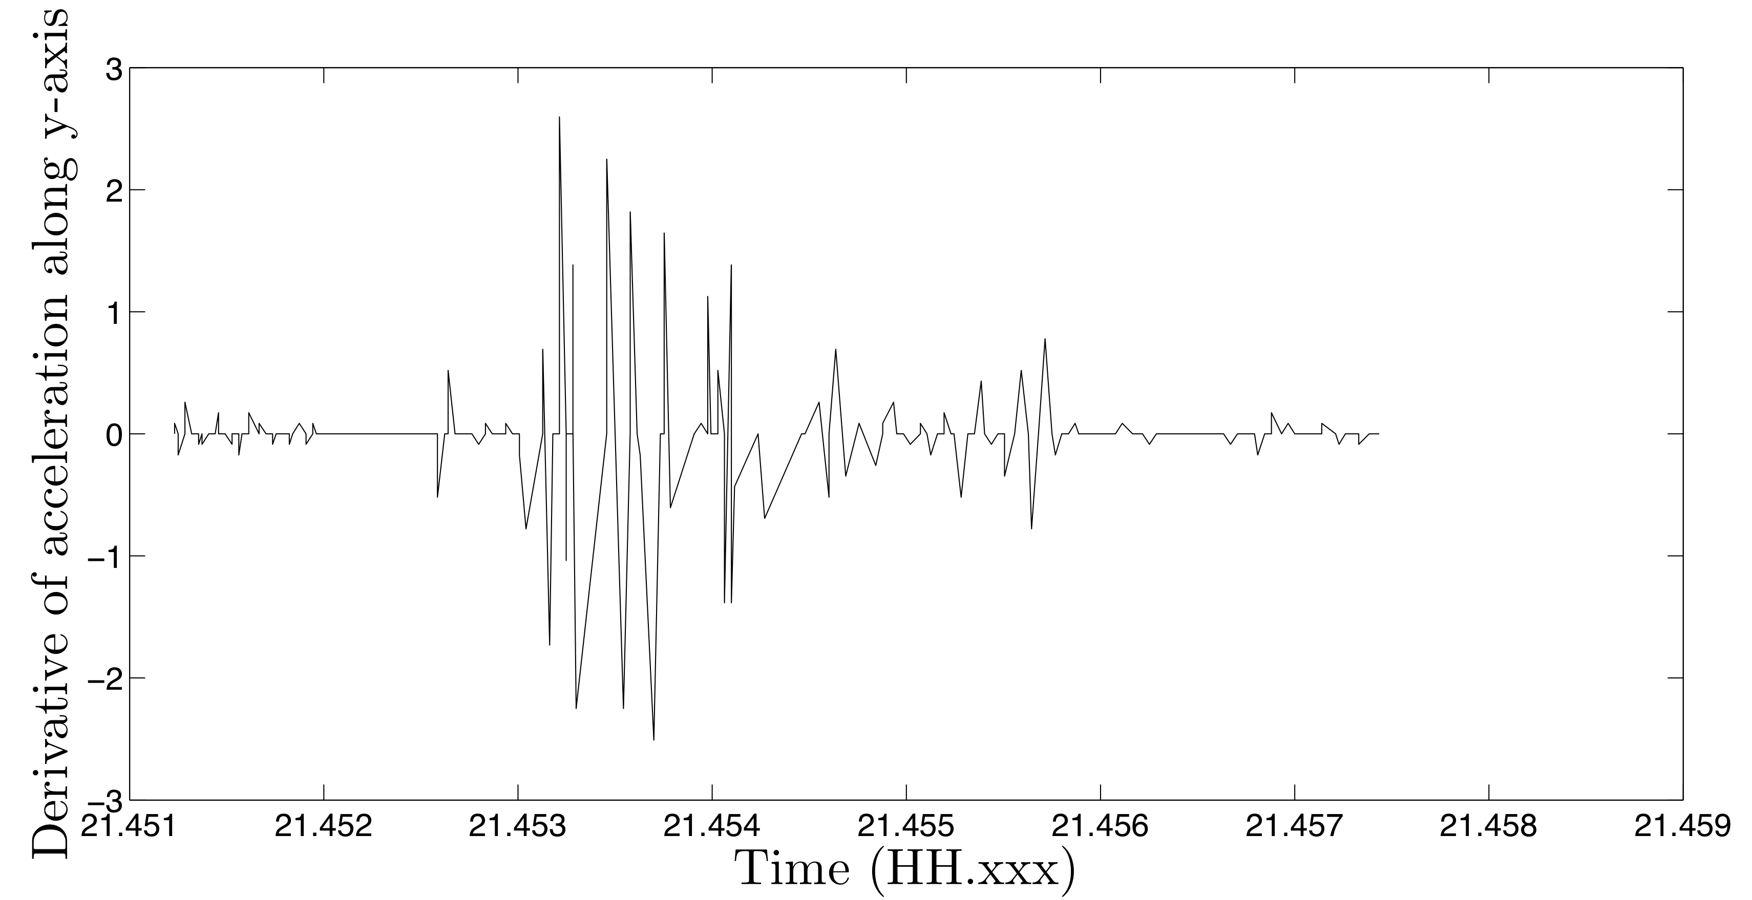

Figure 11 - Accelerometer Reading along y-axis during a Movement

Our algorithm to extract movement events from derivatives of y and z-axes accelerations of the three tags is as follows: For each axis of each tag, we record timestamps when the reported reading is outside the interval [+a, -b]. We consider each of these moments a possible movement. Note that the three tags do not report values synchronously. We calculate the total number of movements reported by the three tags within each two second time window. If the total number of movements within a time window is less than a predefined threshold, we consider those as discrete movements that do not affect sleep quality. We then cluster the other time windows, when a significant number of movements take place, using the DB-SCAN clustering algorithm (Ester 1996) to compute discrete movement events. The clustering also ensures that discrete movement events that happen within a short amount of time are combined as a period of restlessness. For each cluster, we set the movement level as the maximum of movement levels of all the time-windows belonging to that cluster.

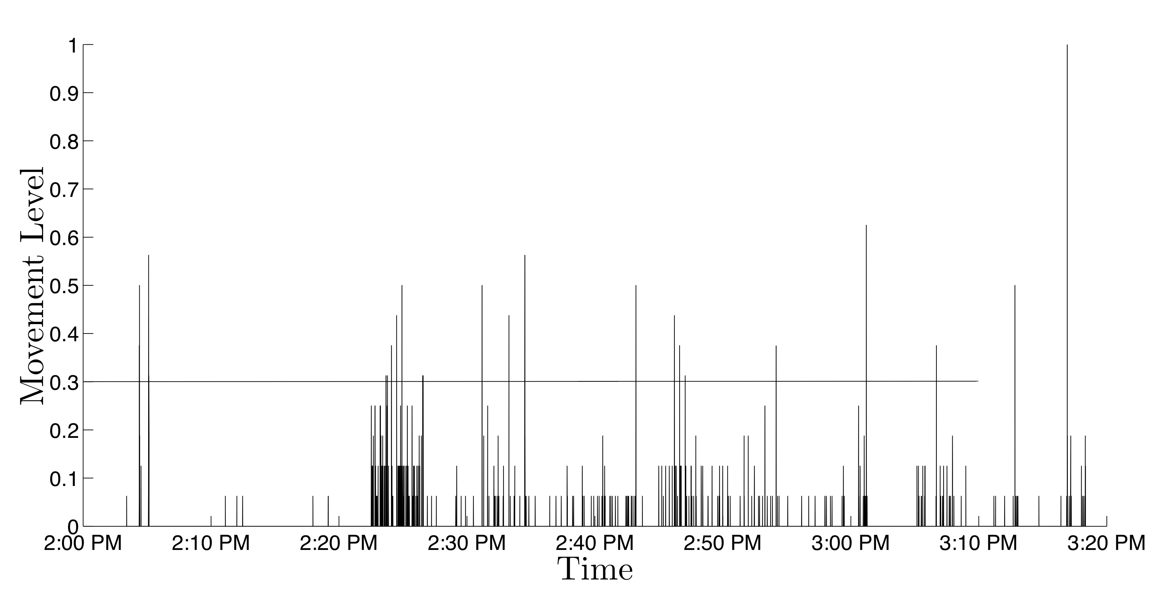
Figure 12 - Number of Movements per each Two-second Time-window during 70 Minutes of Controlled Experiment

Figure12 shows the number of movements for each 2 second time window during 70 minutes of a controlled experiment. During the experiment, the subject got on the bed, laid there for 70 minutes during which he made several movements and finally got off the bed. Some movements were from one body position to another and in some cases, the subject made significant movements while remaining in the same body position. We normalize the y-axis by dividing the number of movements for each time window by the maximum number of movements in any time window to get the movement level. We use 0.3 as the threshold to filter out the time windows where movement level is insignificant.

Figure 13 shows the discrete movement events as clustered by DB-SCAN. All the discrete movement events during the controlled experiment were successfully detected by our system. As we can see from Figure 13 some movement events span several minutes. During these movement events, the subject made a number of movements in quick succession. We comprehensively validate the performance of our movement detection algorithm by realistic overnight experiments that we present in the next section.

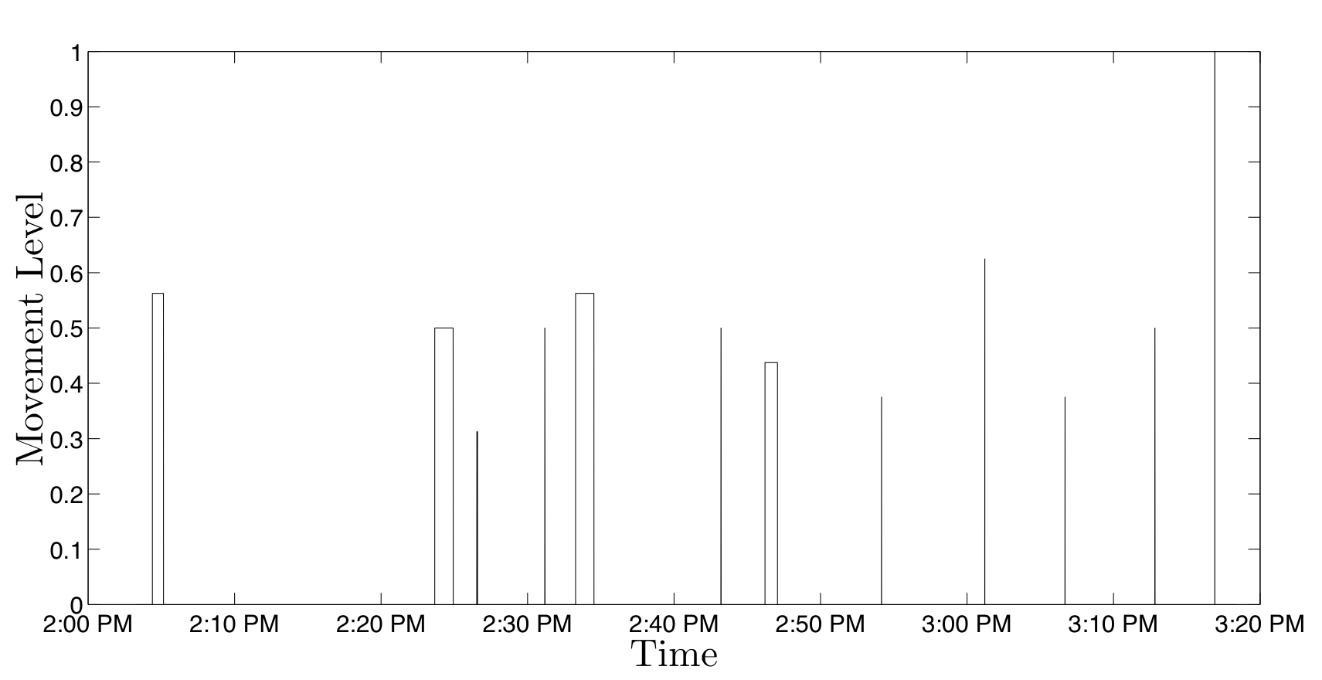

Figure 13 - Discrete Movement Events during 70 Minutes of Controlled Experiment

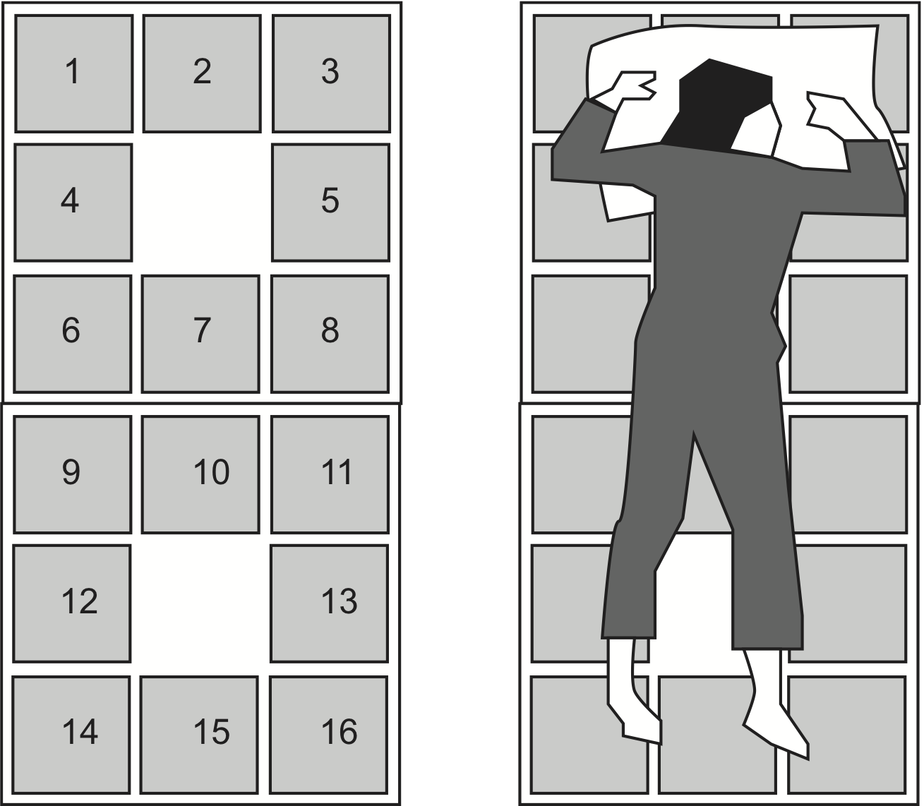
Figure 14 - The DDR Pad has 8 binary contact buttons around the side, but the middle portion of the pad does not have a button. We tiled two pads can cover a twin size bed.

To evaluate the performance of our movement detection algorithm, we compare it with a baseline system that uses pressure pads to measure the movement levels. The pressure sensor we used was a USB-interface Multi-Platform Dance Dance Revolution (DDR) pad typically used in the popular DDR video game series. The configuration of the pad is shown in Figure 14. Two pads were tiled to cover the area of a twin size bed. Data collected from the DDR pad is a bit-vector of size 16 representing which of the 16 buttons are activated. Our algorithm examines a time window, and takes the sum of the number of changes occurring in this bit-vector in that window. We chose a window size of two seconds, same as we did for WISP tags. After calculating the number of movements during each two-second-time window during the night, we clustered them in the same way as discussed in the previous section.

We also compare the performance of our system with an iPhone-based sleep monitoring application SleepCycle that uses accelerometer data to infer sleep quality. The application requires the iPhone to be placed on a suitable position of the bed (e.g., beside the pillow) all night and it collects data from the accelerometer of the iPhone for the whole night. Based on the data, it produces sleep quality related data that includes transitions between different sleep cycles. Durations of different sleep cycles over the course of the night are part of a person's sleeping pattern. So monitoring the transitions between sleep cycles helps in identifying irregular sleeping patterns. Our hypothesis is that transitions between the sleep cycles will correspond to higher number of movements per time window. So from our overnight report of number of movements during each time window, we can infer the transitions between sleep cycles and the duration of each of them. We test our hypothesis in this section.

The study participant slept on the same bed for six nights. We collected and logged data from the DDR pads and the WISP devices simultaneously, and also placed an iPhone on the bed (beside the pillow) during each of these six nights. The SleepCycle application recorded sleep quality data and produced a report for each night. We also videotaped the sleeping period of the subject for each night after being given the subject's consent. We first validated the performance of the DDR pads in detecting movements during sleeping by comparing it with the video data for the first three hours of the recorded data for the first night. The validation result confirmed that the DDR pads could be used as ground truth to detect movements during sleeping. For evaluation, we use a cross validation approach. For each evaluation set, we choose five nights' data to train our system and evaluate the performance for the remaining night's data. So, there are six possible sets of training data. Thus, we have six sets of evaluation.

For each evaluation set, training of the movement detection algorithm includes calculating the thresholds of rate of change of acceleration values (i.e., values of a and b) along each axis for each tag and also the threshold to filter out the time windows where movement level is insignificant. During training, we consider movements detected by the DDR pads as ground truth. Training of the body inference algorithm includes training the Bayesian classifier with the accelerometer readings collected during the five nights with the corresponding body position. Collecting the actual body position for each time instant of each of these five nights is challenging. One option was to monitor the recorded video for each night and assign body positions accordingly. But this requires significant effort. To reduce effort, for each night, we watch the initial body position from the video and from then on we assume that unless there is a movement detected by the DDR pads, the position remains unchanged. When the DDR pads detect a movement, we fast forward to that time instant and see the new body position from the video and we continue in this way. Thus, we collect the ground truth for body position.

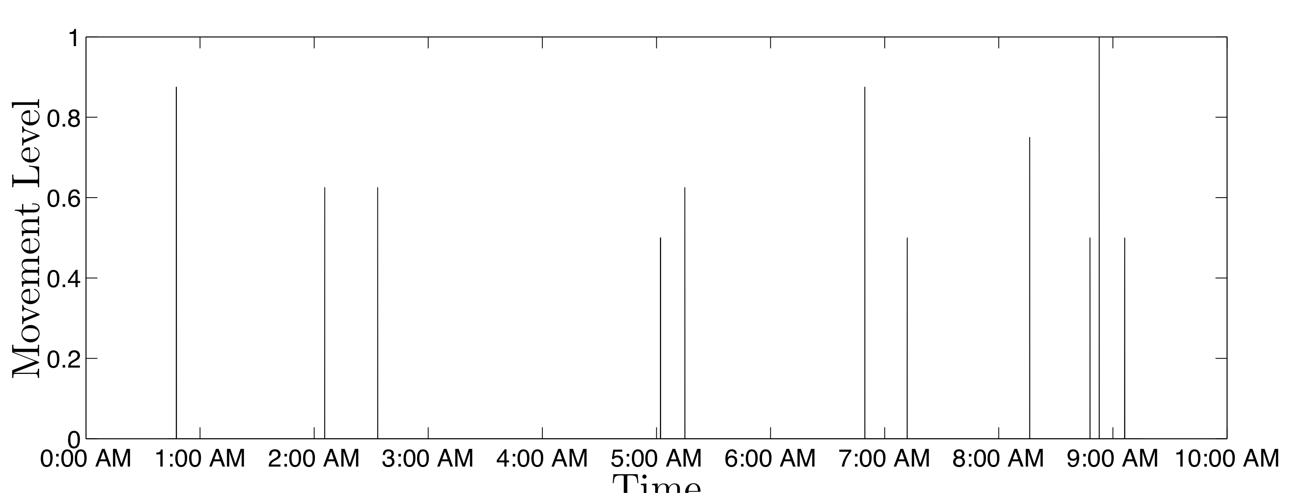

Figure 15 - Movement determined by Our System during One Night's Sleep of Evaluation Set 1

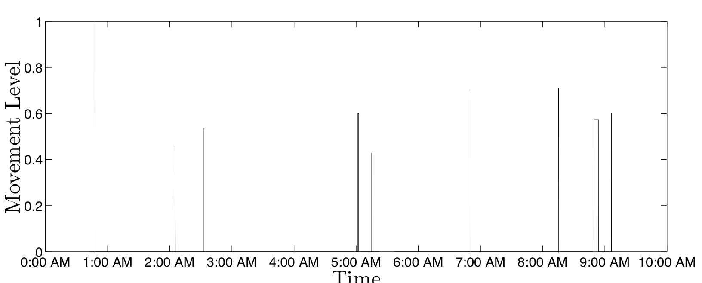
Figure 16 - Movement Determined from the DDR Pad during One Night's Sleep of Evaluation Set 1

Figures 15 and 16 show the movement events during one night's evaluation (from the first evaluation set) of the subject as detected by the WISP tags and DDR pads, respectively. If we compare these two figures, the first and last movements on both the figures represent the events when the subject got on and off the bed, respectively. Our system reported all movement events detected by the DDR pads. The timings of the movements are same in both figures. There was one movement that our system reported, but the DDR pads did not. It happened just after 7:00 AM in the morning. To investigate this incident, we fast forwarded to that specific time of the recorded video and observed that there was no significant movement during that time. So it was indeed a false positive.

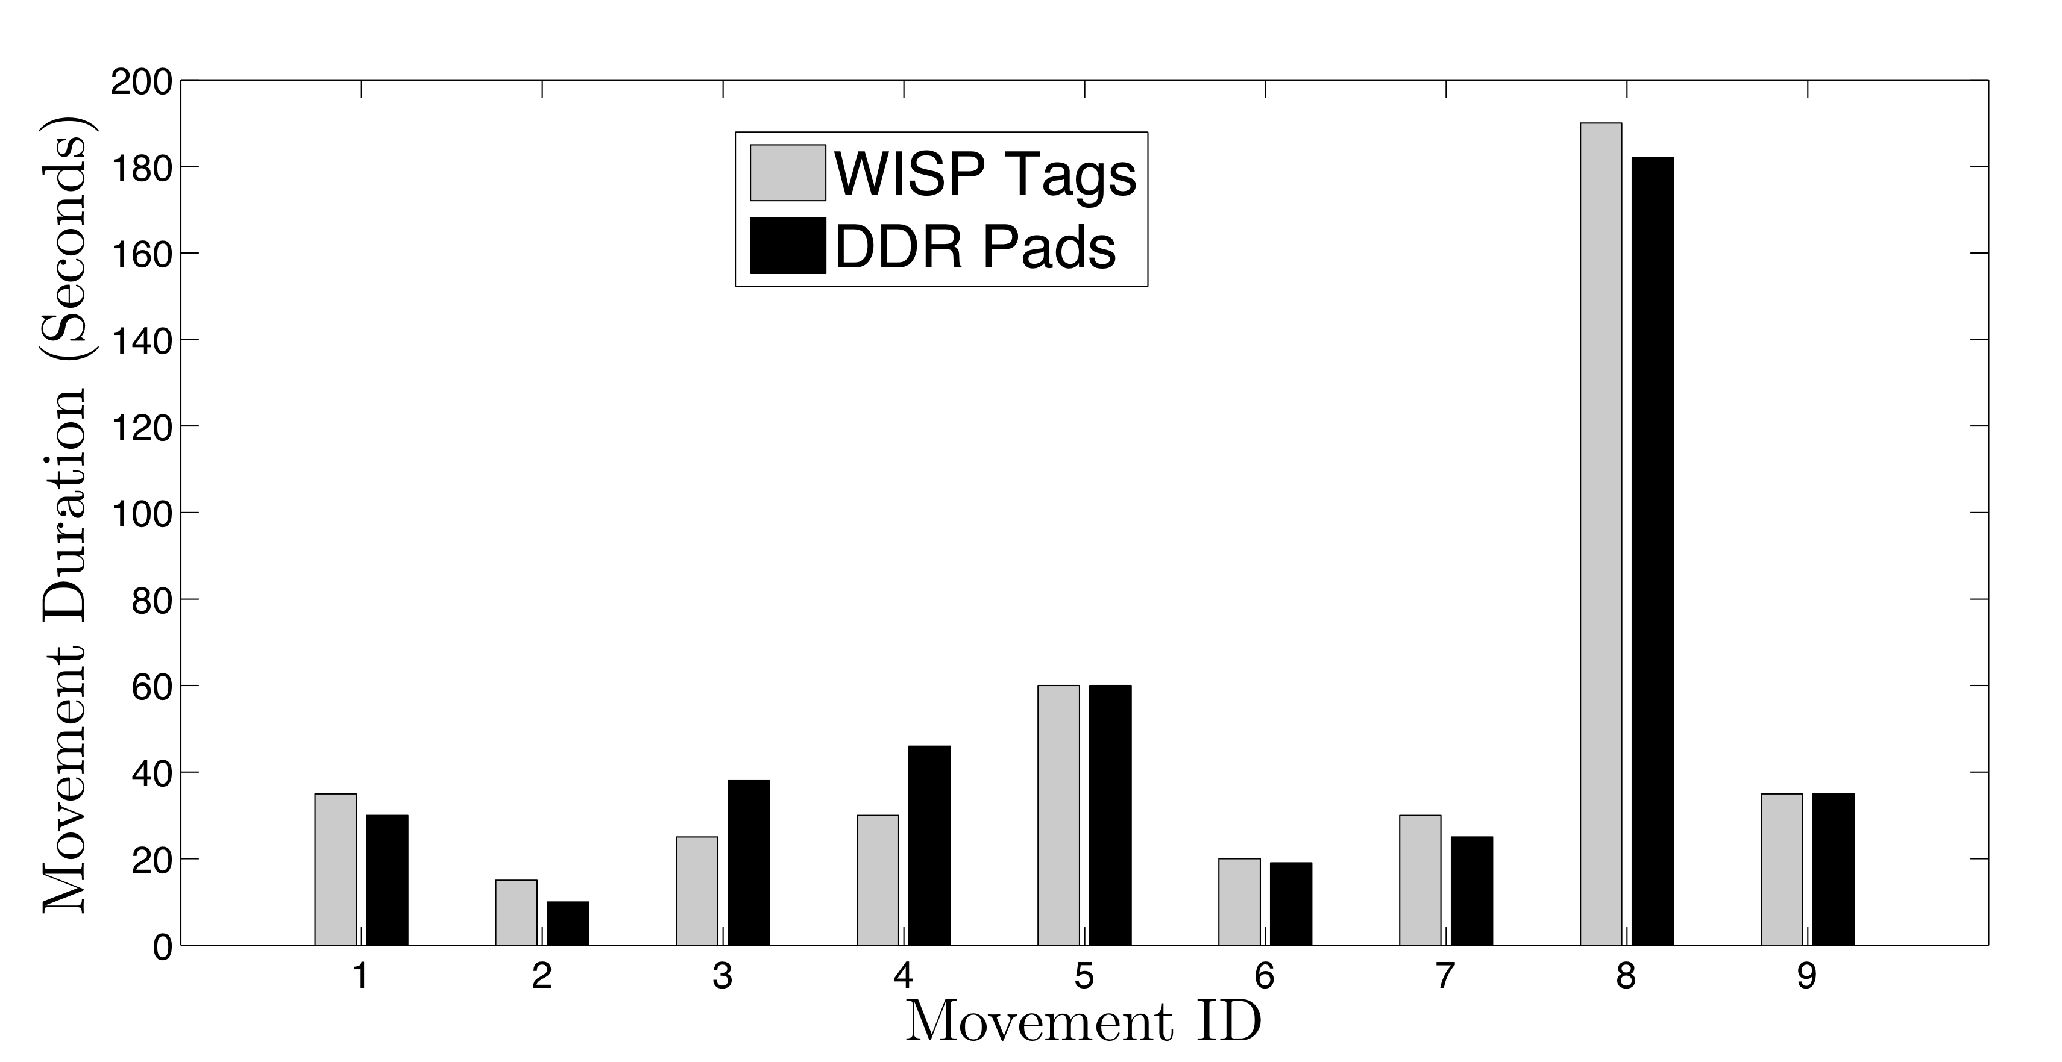

Figure 17 - Durations of the Movements Detected by Our System and DDR Pads

Another notable difference occurred just before 9:00 AM in the morning, when our system reported two movement events and the DDR pads reported one movement event. However, the two events reported by our system are very close to each other and can be considered a part of the same movement. The duration of the nine movements during this night that both systems detected are shown in Figure 17. From this figure, we see that there are no notable differences between the duration of movements calculated by both the systems. We present a summary of results and their implications for all six evaluation sets at the end of this section.

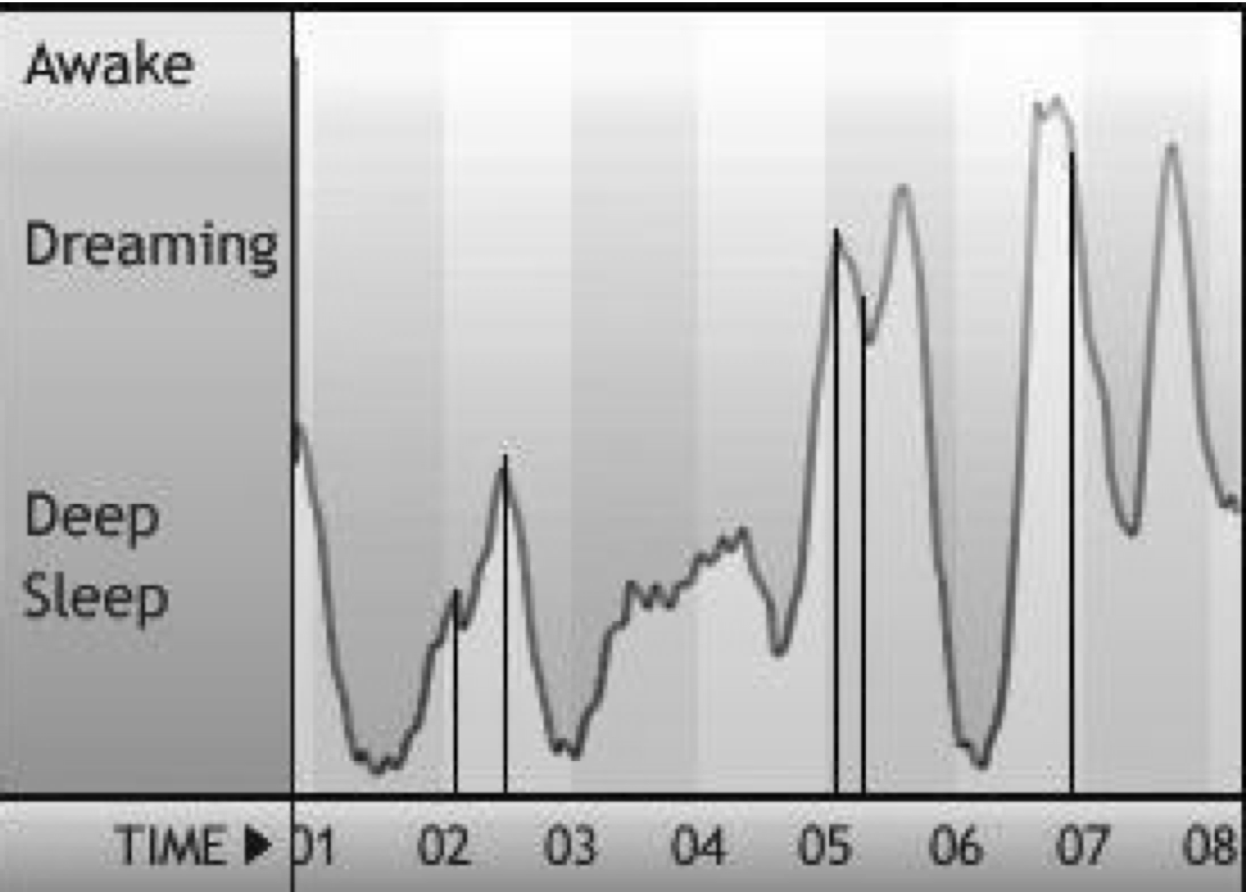

Figure 18 - Sleeping Quality Report Produced by the iPhone Application

Figure 18 shows the report produced by the iPhone application SleepCycle to show the sleep quality for the same night as shown in Figures 15 and 16 The application shows various sleep stages like ‘awake’, `deep sleep' and `dreaming'. These sleep stages are irrelevant for our comparison. The application recorded data up to 8:00 AM in the morning. The vertical bars show when movement events are reported by our system. As we know, transitions between different sleep cycles correspond to movements made by a person. From the figure we can see that the timings of the movement events match to those of transitions between sleep cycles. There are no vertical bars for two transitions: one that happened between 7:00 and 8:00 AM and the other in between 4:00 AM and 5:00 AM. During the latter one, the subject was in deep sleep stage before and after the transition. So this is why there were no major movements. We explain the reason of lack of movements during this transition at the end of this section. But this result proves our hypothesis that from the frequency of movements reported by our system, it is possible to infer transitions between sleep cycles. In addition, our system provides fine-grained body position monitoring which the “Sleep Cycle” application does not.

Evaluation of Body Position

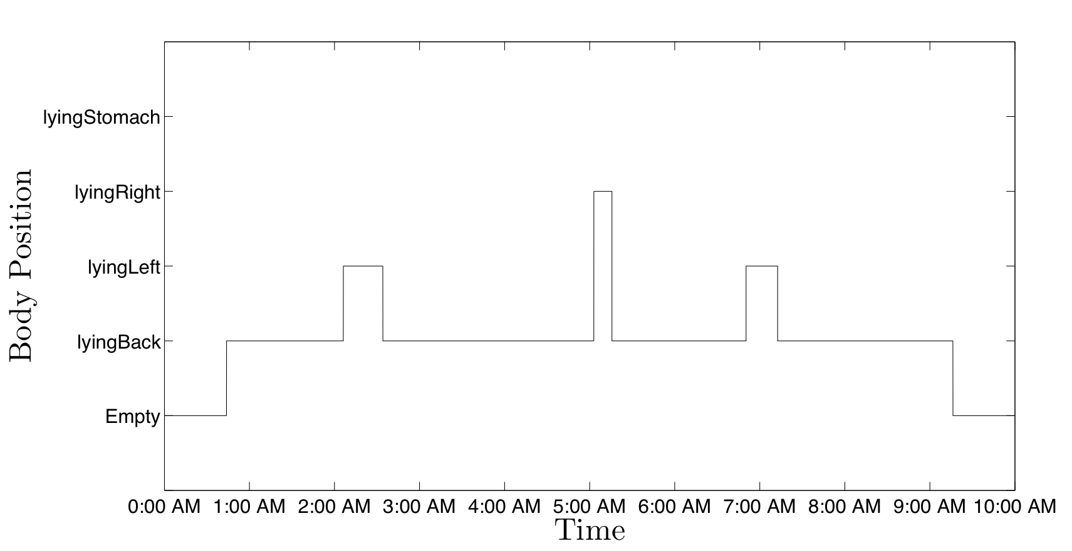

Figure 19 - Body Positions During One Night's Sleep of Evaluation Set 1

Figure 19 shows the body positions as inferred by our system for the same night that was considered in Figures 15, 16, and 18. If we compare these four figures, we see that during each transition from one body position to another, there was a discrete movement event detected by our movement detection algorithm. Also, for the last three movements, the body position did not change. To ensure robustness against discrete erroneous classifications, we consider that the subject changed his body position if 20 successive instances are classified as the new body position. Also, if the movement detection algorithm detects that a movement is taking place, the body position is considered to be the same as it was before the movement until the movement is complete.

To evaluate the performance of the body position inference algorithm of our system, we generate 10 random instances of time for each night and check the subject's body position during each of those instances. For each night, the time instances are uniformly distributed over the course of the night. We define the accuracy of our inference algorithm to be the percentage of time instances when the body position inferred by our system match to the actual body position as seen from the recorded video data. We present the accuracy for each night as part of the summary of all results next.

Evaluation Set | 1 | 2 | 3 | 4 | 5 | 6
False Negatives | 0 | 0 | 0 | 0 | 0 | 0
False Positives | 1 | 0 | 0 | 1 | 0 | 0
Avg. Error in Movement Detection | 6.9s | 6.2s | 2.2s | 5.2s | 4.1s | 5.2s
Sleep Cycle Detection Accuracy | 71.4% | 75% | 80% | 75% | 90% | 80%
Body Position Inference Accuracy | 100% | 100% | 100% | 90% | 100% | 90%
Table 1: Summary of Results for Six Datasets

Table 1 presents a summary of results for our six sets of evaluation. False negatives refer to the number of movement events that are detected by the DDR pads, but not by our system. Similarly, false positives refer to the number of movement events that are detected by our system, but not by the DDR pads. For each night, we define `average error in movement duration' as the average of absolute differences between the movement durations calculated by our system and the DDR pads. Sleep cycle detection accuracy refers to the percentage of sleep cycle transitions (as shown by the iPhone application) that correspond to increased number of movements detected by our system.

From Table 1 we see that for each set, our system detected all the movement events detected by the DDR pads. Average error in calculating movement duration is less than six seconds for each night. But, for two nights, we observe one false positive each in our system. This may be due to the threshold in change of acceleration that we selected to filter insignificant movements. We believe by training the system for more nights, we can get rid of such false positives. Overall, our system shows 100% accuracy in detecting discrete movement events and calculates the durations of each movement with reasonable accuracy. The accuracy of the body position inference algorithm is at least 90% for all sets. Our evaluation was based on 10 randomly selected time instances that are uniformly spread over one night. More detailed evaluation is necessary to guarantee its performance. Therefore, we can say that, with proper training, our system performs as well as a system that uses pressure sensors and also is more comfortable for the users and completely unobtrusive. Moreover, our system provides fine-grained body position monitoring which no existing pressure sensor based sleep monitoring system provides.

We also compare our system with the popular iPhone based application “Sleep Cycle”. Comparison results show that by only looking at the movement reports of our system, it is possible to identify most of the transitions between sleep cycles. Among the transitions that were not possible to identify, most of them were during deep sleep stages. The pressure sensors also did not identify them. So, these types of transitions do not correspond to significant body movements. We need to lower the value of the threshold for filtering out insignificant body movements which was set assuming the DDR pads' detected movements as ground truth. Therefore, we can say that, by training our system with the transitions detected by the iPhone application, it is possible to detect all the transitions between sleep cycles by our system.

Comparison with Zeo

The Zeo device has been compared against polysomnography in several clinical studies (Wright 2008, Fabregas 2009, Shambroom 2009). The Zeo, via a headband, monitors electrical signals around the head to infer the sleep stage of the wearer. Zeo’s SoftWave algorithm uses a neural network to classify each 30 seconds into the sleep stages ‘wake’, ‘REM’, ‘light sleep’ (stages 1-2), and ‘deep sleep’ (stages 3-4).

We collected preliminary data to explore the relationships between the data collected by the Zeo and the WISP tags. For this experiment, we used a single sleeper on a twin-sized mattress. For seven nights, the subject wore both the Zeo headband and slept on a WISP instrumented bed. Eight WISP tags were used on the bed. The Zeo reported the sleep stage prediction results every 30 seconds, so correspondingly, we used a 30 second sliding time window on the WISP data and the movement levels on each accelerometer to extract the variation of the time signal. After the signal has been Z-normalized, values over a threshold of 2-sigma were classified as a ‘movement event’. The result was binary data recognizing periods of movement in the sleep as shown in Figure 20.

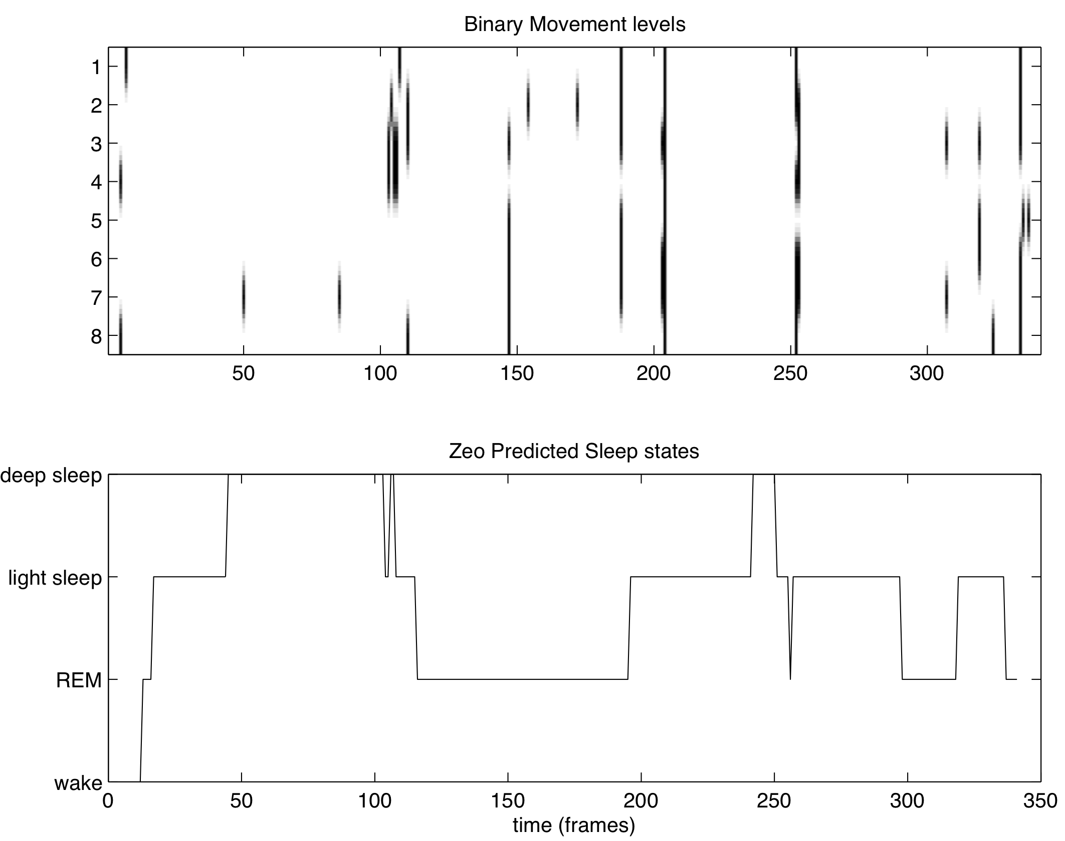
Figure 20 – One night’s sleep period comparing the movement data with the Zeo

Next we use a Naïve Bayesian classifier to classify the sleep stages. 15% of the data was used for testing, and the other 85% was used for training. We received poor classification accuracy especially with the REM, light sleep, and deep sleep. Next we trained a dynamic neural network using 70% as training data, and 20% for testing. The performance of the regression R values was 0.28 during testing with a mean squared error (MSE) of 0.64. In this very preliminary study with a single subject, there seems to be little correlation between the four sleep stages Zeo predicted and the features from the WISP tags.

Next, we limited the scope from predicting four sleep stages, to just two, sleeping vs. wake. Our dataset had 4285 frames for all the sleeping periods and 189 frames of wake periods. Our hypothesis was that wake periods receive more movement than sleep stages. We performed a one-tailed t-test on the two distributions assuming unequal variances. The null hypothesis was rejected with a p of 0.0017 that wake stages receive more movement than sleep stages with a mean of 1.59 vs. -0.07 standardized movements per frame. When the person first enters the bed and just prior to leaving the bed there is large period of movement. These preliminary results show that there could be a relationship with movement and consciousness. However, accurate segmentation of the time regions where someone drifted into sleep from being awake is a challenging and open problem. Future research once addressing this issue could then determine the ratio of the time sleeping vs. time spent in bed (sleep efficiency), which is an important metric when determining sleep quality. It will also be important to study both good and poor sleepers.

Previous research (Cole 1992) shows that wrist activity data collected when the user wears a wrist actigraph during sleep can be used to distinguish sleep from wakefulness with over 88% accuracy in a mixed sample including normal control, elderly individuals, sleep disorder patients, psychiatric patients and others. They do it using an automatic scoring algorithm that takes into account amount of movement in the current and adjacent time windows. A later study (Kogure 2011) formulates an automatic sleep/wake scoring algorithm that uses activity measurements obtained using a highly sensitive pressure sensor placed under the mattress. Results show that the pressure pad placed under a mattress or a futon can produce almost identical sleep/wake scores to actigraph. For our WISP based sleep monitoring system, similar medical studies need to be done to formulate an automatic sleep/wake scoring algorithm validated using a variety of patients.

Conclusion
In this chapter, we have described the use of WISP tags for monitoring sleep. We have compared our solution to other solutions and now briefly summarize the various sleep monitoring sensors and their tradeoffs in Table 2.We have shown that movement and body position can accurately be monitored with WISP tags. Furthermore, the WISP tags have a high comfort level since they are not on the sleeping surface and no device needs to be worn on the body. Our results also show that the recognition accuracy is similar to pressure sensors, but at a lower price and less intrusiveness. One main advantage of using WISP tags is that our system provides fine-grained body position monitoring which none of the existing systems offer. We plan to use our sleep monitoring system for monitoring restlessness of incontinence patients during sleep and also for depression studies where the goal is to monitor the sleep quality of patients suffering from clinical depression.

In the future we will consider the radiation caused by the reader since a long time period of exposure is expected, and further investigate the relationship between the amount and types of movement and sleep stages. We will also improve our algorithm to make our system usable in different scenarios e.g., in houses where there are pets, and where multiple people sleep in the same bed.

Device | Comfort | Privacy | Accuracy | Price
WISP Tag | High | Good | High | Moderate
Pressure Sensor | Medium | Good | High | Moderate
Camera | High | Very Low | Excellent | High
EEG/Actiwatch | Very Low | Good | Excellent | High
Zeo | Low | Good | High | High
Table 2- Qualitative Comparison Across Devices

ACKNOWLEDGEMENTS
This work was supported, in part, by NSF grants ECCS-0901686 and IIS-0931972. The WISP tags were donated by Intel as part of the WISP challenge.

REFERENCES
M. Buettner, R. Prasad, M. Philipose, and D. Wetherall (2009). Recognizing Daily Activities with Rfid-based Sensors. In Proceedings of the 11th International Conference on Ubiquitous Computing (Ubicomp '09). ACM, New York, NY, USA, 51-60.

M. Carskadon and W. Dement (1989). In M.H. Kryger, T. Roth and W.C. Dement, (Ed.), Principles and Practice of Sleep Medicine, W B Saunders, Philadelphia, PA.

R. Chaudhri, J. Lester, and G. Borriello (2008). An RFID Based System for Monitoring Free Weight Exercises. In Proceedings of the 6th ACM Conference on Embedded Network Sensor Systems (SenSys '08). ACM, New York, NY, USA, 431-432.

R. J. Cole, D. F. Kripke, W. Gruen, D. J. Mullaney, and J. C. Gillin (1992). Automatic Sleep/Wake Identification from Wrist Activity. Sleep, 15(5), 461 – 469.

J. Demsar, B. Zupan, G. Leban, and T. Curk (2004). Orange: From Experimental Machine Learning to Interactive Data Mining. In ECML/PKDD, Volume 3202, (pp. 537-539).Springer Berlin / Heidelberg.

H. V. der Loos, H. Kobayashi, G. Liu, Y. Tai, J. Ford, J. Norman, T. Tabata, and T. Osada (2001). Unobtrusive Vital Signs Monitoring from a Mulitsensor Bed Sheet. In RESNA, 2001.Arlington, VA.
M. Ester, H. Kriegel, J. Sander, and X. Xu (1996). A Density-based Algorithm for Discovering Clusters in Large Spatial Databases with Noise. In Evangelos Simoudis, Jiawei Han, and Usama Fayyad (Eds.) The Second International Conference on Knowledge Discovery and Data Mining (KDD-96).
E. Hoque, R. Dickerson, and J. Stankovic (2010). Monitoring Body Positions and Movements During Sleep using WISPs. In Wireless Health’ 10. San Diego, USA.

S. Fabregas, J. Johnstone, J. Shambroom (2009). Performance of a Wireless Dry Sensor System in Automatically Monitoring Sleep and Wakefullness. Sleep 2009; 32: A388. Abstract 1189

F. Giganti, G. Ficca, S. Gori, and P. Salzarulo (2008). Body movements during night sleep and their relationship with sleep stages are further modified in very old subjects. Brain Research Bulletin, 75(1), 66-69.

W. Karlen (2009). Adaptive Wake and Sleep Detection for Wearable Systems. PhD thesis, Ecole Polytechnique Federale de Lausanne (EPFL).

T. Kogure, S. Shirakawa, M. Shimokawa, and Y. Hosokawa (2011). Automatic Sleep/Wake Scoring from Body Motion in Bed: Validation of a Newly Developed Sensor Placed under a Mattress. Journal of Physiological Anthropology, 30(3), 103 - 109

K. Krauchi, C. Cajochen, and A. Wirz-Justice (2004). Waking Up Properly: Is There a Role of Thermoregulation in Sleep Inertia? Journal of Sleep Research, 13(2), 121-127.

D. Mack, M. Alwan, B. Turner, P. Suratt, and R. Felder (2006). A Passive and Portable System for Monitoring Heart Rate and Detecting Sleep Apnea and Arousals: Preliminary Validation. Distributed Diagnosis and Home Healthcare: (pp. 51-54). Arlington, VA.

D. Mack, S. Kell, M. Alwan, B. Turner, and R. Felder (2003). Non-invasive Analysis of Physiological Signals (naps): A Vibration Sensor that Passively Detects Heart and Respiration Rates as Part of a Sensor Suite for Medical Monitoring. In 2003 Summer Bioengineering Conference.

A. Oksenberg and D. Silverberg (1998). The Effect of Body Posture on Sleep-related Breathing Disorders: Facts and Therapeutic Implications. Sleep Medicine Reviews, 2(3), 139-162.

Ya-Ti Peng, Ching-Yung Lin, Ming-Ting Sun (2006).Multimodality Sensors for Sleep Quality Monitoring and Logging.22nd International Conference on Data Engineering Workshops (ICDEW'06): (p. 108).

S. Redmond and C. Heneghan (2006). Cardio Respiratory-based Sleep Staging in Subjects with Obstructive Sleep Apnea. IEEE Transactions on Biomedical Engineering, 53(3), 485-496.

A. Sadeh and C. Acebo (2002). The Role of Actigraphy in Sleep Medicine. Sleep Medicine Reviews. Sleep Medicine Reviews, 6(2), 113-124.

A. P. Sample, D. J. Yeager, P. S. Powledge, A. V. Mamishev, and J. R. Smith (2008). Design of an Rfid-based Battery-free Programmable Sensing Platform. IEEE Transactions on Instrumentation and Measurement, 57(11), 2608 - 2615

J. Shambroom, J. Johnstone, and J. Fabregas (2009). Evaluation of Portable Monitor for Sleep Staging. Sleep A386. Abstract 1182.

Z. Shinar, S. Akselrod, Y. Dagan, and A. Baharav (2006). Autonomic Changes during Wake-sleep Transition: A Heart rate Variability based Approach. Autonomic Neuroscience, 130(1-2), 17-27.

A. Wood, J. Stankovic, G. Virone, L. Selavo, Z. He, Q. Cao, T. Doan, Y. Wu, L. Fang, and R. Stoleru (2008).Context-aware Wireless Sensor Networks for Assisted-living and Residential Monitoring. IEEE Network, 22(4), 26-33 .

Y. Yang, J. Shin, S. Jang, H. Lee, and Y. Yoon (2006). Research of Body Movement during Sleep with an Infrared Triangulation Distance Sensor, Wavelets and Neuro-fuzzy Reasoning. In IFMBE, 14(7), 760-763.

D. Yeager, J. Holleman, R. Prasad, J. Smith, and B. Otis (in press). Neuralwisp: A Wirelessly Powered Neural Interface with 1-m range. IEEE Transactions on Biomedical Circuits and Systems.

K. Wright, J. Johnstone, S. Fabregas, J. Shambroom (2008). Evaluation of a Portable, Dry Sensor-Based Automatic Sleep Monitoring System. Sleep. 2008; 31. A337. Abstract 1023.

Sleep cycle. Retrieved June 16, 2011 from: http://www.lexwarelabs.com/sleepcycle/.

Sleep related problems. Retrieved June 16, 2011 from: http://www.sleepfoundation.org/articles/sleep-related-problems

Bed alarm sensor pad. Retrieved June 16, 2011 from:
http://www.1800wheelchair.com/asp/view-product.asp?product_id=3060

Philips actiwatch. Retrieved June 16, 2011 from:http://www.actiwatch.respironics.com/.

Wisp: Wireless identification and sensing platform. Retrieved June 16, 2011 from:http://www.seattle.intel-research.net/wisp/

Zeo personal sleep coach. Retrieved June 16, 2011 from:http://www.myzeo.com/.

