Determining Web Usability Through an Analysis of Server Logs

A Thesis
in TCC 402

Presented to

The Faculty of the
School of Engineering and Applied Science
University of Virginia

In Partial Fulfillment
of the Requirements for the Degree
Bachelor of Science in Computer Science

by

Julie Vogelman

03/26/01

On my honor as a University student,
on this assignment I have neither given nor received
unauthorized aid as defined by
the Honor Guidelines for Papers in TCC Courses.

____________________________________________________

Approved ___________________________________________________
(David Evans)

Approved ___________________________________________________

(Rosanne Welker)

Table of Contents

List of Figures/Tables…………………………………………………………………iii
Abstract………………………………………………………………………………..iv

Chapter 1: Introduction………………...………………………………………………1
  - Rationale………………………...…………………………………………….1
  - Framework…………………...………………………………………………..1
  - Preliminary Research….……………...……………………………………….3
    - Usability of Web Sites…………………….……...……………………4
    - Log Analysis……………………….………………...………………...5
  - Overview of the Rest of the Report………………………………………...…7

Chapter 2: Framework…………………………………………………………………8
2.1. Random Redirection…………………………………………………………..8
  - Log Analysis Tool……………………………………………………………10

Chapter 3: Experiments……………………………………………………………….12
  - Arial vs. Times New Roman Font…………………………………………...12
  - The Ideal Quantity of Bold Text…………………………...………………...16
    - Setup of the Experiment………………………………………………16
    - Results of the Experiment…………………………………………….19

Chapter 4: Conclusions……………………………………………………………….21
  - Interpretations…………………………………………………………...…...21
  - Recommendations……………………………………………………...…….22
Works Cited…………………………………………………………………………..24
Bibliography…………………………………………………………………………..25
Appendix A: Questionnaire from Web Usability Experiment…………….………….26
List of Figures/Tables

Figures:
1.1: Graphical Depiction of the Framework…………………………………………...2
3.1: Version 1 of the download.html page: Arial font………………………………..14

3.2: Version 2 of the download.html page: Times New Roman font ………………..14
3.3: Version 1 of the User’s Guide page: Arial Font…………………………………15
3.4: Version 2 of the User’s Guide page: Times New Roman Font………………….15
3.5: Version 1 of the Front Page……………………………………………………...17
3.6: Version 2 of the Front Page…………………………………..………………….17

Tables:

Table 2.1: Original Format of the page produced by cron_session.pl………….…….11

Table 2.2: Revised Format of the page produced by cron_session.pl………..………11

Table 3.1: Results of Experiment on Font……………………………………………13

Abstract

Almost half of American companies currently conduct business online. Knowing how to create usable web sites is valuable information for companies on the World Wide Web, since providing a satisfactory web experience will encourage clients to stay with the company rather than seek out the competition. Although there is a lot of research already available on the subject of creating usable web design, the research is incomplete. To close one gap in the research, I have built a framework for analyzing users’ reactions to web sites. The application accepts two versions of a web site and redirects half of users to one version and half to the other. It then analyzes log files to compare how users reacted to each of the two versions, including how long users spent on each page before leaving and which links they selected. This project also used the framework to compare the usability of Arial font to that of Times New Roman and found Arial to be more usable. A second, more tightly controlled experiment sought to identify the ideal quantity of bold text on a web page.

Chapter 1. Introduction

What are the characteristics of a well designed web site? To answer this question, I have built a framework for comparing users’ reactions to multiple versions of a web site. The application randomly redirects users to one of two versions of a web site, and then analyzes log files to compare how users reacted to each of the two versions, so as to draw conclusions as to which version of the site was preferred. Specifically, the application analyzes the average amount of time spent on each page of the site for each version, and compares them. To prove the usefulness of this framework, I conducted two experiments. The first experiment compared the usability of two different fonts, and found Arial font to be more usable than Times New Roman. The second sought to identify the ideal quantity of bold text on a web page.

1.1 Rationale
Almost half of companies in the United States conduct some or all of their business online [3]. Financially, they are dependent on the design of their web sites. Customers will take their business elsewhere if a company’s site is difficult to use. In the last few years, many books have been written on the subject of web design. Much of this information, however, is theoretical and has not been formally tested. Additionally, there is information missing on the subject. As an example, companies use bold text to attract users to certain links that they want them to follow. However, is there a point at which too much of the text can be bolded, such that the user is confused and is no longer influenced by the bold text? How much bold is too much? This is just one example of a very specific question that has not been answered by web design research.

1.2 Framework
To close one gap in the field of web design, I have designed a framework for comparing users’ reactions to multiple versions of a web site. The tool accepts two versions of a web site, which differ by one variable. Users are redirected to one of the two versions of the web site based on whether their IP addresses end in an odd or even number, and log files are compiled based on these visits. Perl scripts are then used to analyze the log files to determine which of the two versions of the site, if either, was preferred. Specifically, the Perl scripts analyze the average amount of time spent by users on each page of the site, and the links that the users tended to click. Figure 1.1 shows a graphical depiction of the framework I have designed.



Users with odd numbered IP addresses
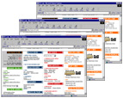
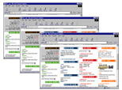
Log Files
Users with even numbered IP addresses
Results

Perl Scripts

Figure 1.1: Graphical Depiction of the Framework

After having built the framework, I was able to conduct a few experiments. First, I conducted an experiment with volunteers from CS 110 on the effects of bold text on a user’s ability to find information. I gave the students a list of questions to answer in regard to the UVA CS web site. Instead of directing them to the actual CS web site, they were shown a mirror of the CS web site on my server. Half of the users were directed to a version of the front page in which 1/8th of the links were bolded; the other half saw a page in which 1/4th of the links were bolded. The purpose of the experiment was to determine how much bold is helpful for quickly finding links. The advantage to this experiment was that I knew the intentions of each of the users, and by analyzing the path that each one took through the site, I was able to determine how the index page affected their choices of links. Surprisingly, my analysis concluded that students who saw the page with ¼ of the links bolded were able to choose links more accurately; however, due to a number of factors, the results of this experiment may simply be coincidental.
The next experiments I conducted did not require a formal gathering of subjects. Rather, I simply produced multiple versions of Professor Evans’ LCLint web site, changed some of these pages, and used the visitors of the site as my test subjects. I compared the relative usability of Arial font to that of Times New Roman font, to determine which was more readable. While my results were similar between the two fonts, they showed that Arial font was slightly more readable.

1.3 Preliminary Research
Prior to building the framework for my log analysis, I researched two subject areas. First, in order to decide on my methods of analysis, I read through different perspectives on web usability. In addition, I researched some of the log analysis tools that are currently on the market. Below is a summary of my findings.
1.3.1 Usability of Web Sites
Due to the recent influx of companies selling on the World Wide Web, there is, more than ever before, a desire to rise above the competition. Rising above the competition often means creating a good, usable web site. Typically, when people buy products, they are not given a chance to test the products before they buy them. However, the web is a unique medium in that the user tests the usability of the site before he makes a purchase [4: 10]. If the site is not easy to use, he will leave and go to a competitor.
Web sites that have usable design are not necessarily artistic, but rather are created with the intention of moving a user through the site quickly [2:137]. They load quickly, and they are read quickly. In a recent survey of Internet users, speed was found to be the biggest problem for Web sites [2:153]. Users do not like having to wait for information and are likely to leave a site if it takes too long to load. It takes only one second for a user’s flow of thought to be interrupted [4:44]. Unfortunately, one second is an unrealistic expectation for loading a page. If a page loads within ten seconds, the user will probably wait patiently, even though his thought flow may have been interrupted. Beyond ten seconds, he will go elsewhere [4:44]. Due to these time constraints, it is recommended that for a site that has many of its users dialing in from an analog modem, pages be no greater than 34 KB in size [4:48].

In order for a user to navigate through a site quickly, the site must be simple. Each page should not be cluttered with text, but rather should include only relevant information, for all irrelevant information diminishes the visibility of relevant information [2:139]. As often as is possible, the page should fit on one screen, since scrolling wastes the user’s time [2:139]. Each page should use ample white space, to allow the user “breathing room” between items. White space also enables the user to appropriately group information into categories [4:18].

The site should be user-oriented rather than system-oriented. It should use language that is familiar to the user [2:139]. The site should also be organized according to the users’ mental models of the content structure. Companies all too often make the mistake of organizing their sites according to the structure of their organization because it is easier that way, yet this structure is often not evident to the user and is not oriented to the user’s tasks [2:157].

In order for it to be usable, the site must also be consistent, because inconsistency causes the user to have to process new information, thereby also slowing him down [2:139]. This includes both external and internal consistency. The site should be consistent with other web sites, and thus behave as the user expects it to. The pages within the site should also be consistent. They should have the same colors and graphical styles. Headers and footers should also remain the same throughout the pages of the site [5:477].

1.3.2 Log Analysis

Seeking to improve the design of their sites, many companies use statistics to discover the types of people who tend to visit their sites, and the pages that they tend to visit within the site. Some companies do their own statistical analysis, while many more either buy software or hire another company to perform the analysis for them. Less than a decade ago, the only products performing web analysis were shareware and freeware. Commercial web analysis programs arrived on the market around 1994, thereby reducing the number of programmers willing to continue to produce the software for free [6:156]. Nevertheless, there are still some free log analysis tools, which are downloadable from the Internet. The commercial tools on the market are generally of better quality and range from $500 to $1,000 [1:280]. For an even steeper price, service companies will perform the analysis for other online companies using their own software and upload the statistics to the web. These companies typically charge a few hundred dollars per month, yet they take much of the work out of performing the analysis oneself. Moreover, whenever the service company upgrades their software, the customer benefits from the upgrade [6:134].

Web analysis software and companies obtain their statistical information from Server Access logs. These logs are available on all servers, and consist of transfer logs, error logs, referer logs, and agent logs. The transfer log provides a list of all hits on the server and the times at which they occurred. The error log, as the name implies, lists all errors that were made to the server. The referer log provides a list of the locations from which users came before entering the site, and the pages that the users hit first within the site. The agent log, finally, lists the web browsers or search engines used by the users in the site [6].
While the web analysis tools have their differences, many of them provide much of the same information, including:
- Most requested pages
- Most requested directories within the site
- Top domains frequenting the site
- Most active organizations
- Most active countries/cities
- Top sites referring users to the site
- Most commonly used browsers
- Most commonly used platforms
- Amount of activity by day of the week, and by hour of the day
- Most common errors
Researching current perspectives on web usability and current methods of log analysis assisted me in deciding upon my own methods of performing my analysis. It helped me to determine which characteristics of usability to analyze, as well as which specific variables of web sites to test. It also introduced me to the process of analyzing server logs.

1.4 Overview of the Rest of the Report
Chapter 2 describes the methods I took when designing the framework for my thesis. Chapter 3 explains the experiments I conducted and the results derived from these experiments. Finally, Chapter 4 provides my conclusion as to the success of my thesis, and recommendations on work that should follow.

Chapter 2. Framework
To build an effective tool for determining the characteristics of good web design, I designed a framework that compared users’ reactions to two versions of a web site. Building this tool required two components. First, I wrote code to randomly redirect users to one of the two versions of the site, to ensure that an equivalent number of users were redirected to one version as the other. Next, I designed a tool to analyze and compare log files from the two versions.
2.1 Random Redirection
My first step was to set up a web server on my machine, which would show half of users one version of a web site and half the other version. I installed Apache on my machine because it is a widely available, open-source web server platform, and thus is freely available. I then set up a web server, to enable my machine, fowler, to serve pages to the web under the URL: http://fowler.cs.virginia.edu.
Once I set up the web server, I changed it so that instead of showing all users the same site, it redirected half of them to one version of the site, and half to the other. Apache has the capability of redirecting users to another page using the command RewriteRule. Below is an example of how RewriteRule might be used:
RewriteRule ^/index.html$ ^/redirected/index.html
In this example, all users who try to access the page, index.html, will be redirected to /redirected/index.html. A second command, RewriteCond, often precedes RewriteRule, to dictate the conditions under which users are redirected. Below is an example of how RewriteCond and RewriteRule might be used together:
RewriteCond REMOTE_ADDR 123.45.67.890
RewriteRule ^/index.html$ ^/redirected/index.html
In this example, the server will only redirect users who have 123.45.67.890 as their IP address.
Although these two functions were helpful, they were not enough to redirect half of users to one site and half to another. Consequently, I altered the code for RewriteCond in the file mod_rewrite.c to enable it to perform this function. To redirect an equivalent number of users to one site as to the other, the code redirectd them based on whether their IP address ended with an odd or even number. This strategy required altering RewriteCond to check the user’s IP address for evenness or oddness. Users with an even-numbered IP address would be redirected to version 1 of the site, while users with an odd-numbered IP address would be redirected to version 2. Here is the final set of commands I used:
RewriteCond REMOTE_ADDR even
RewriteRule ^[.+]$ /version1/$1
RewriteCond REMOTE_ADDR odd
RewriteRule ^[.+]$ /version2/$1
I altered RewriteCond such that it would check for the words “even” and “odd” on the command line. If “even” were passed as a parameter, the function would return true if the IP address were even (thus enabling RewriteRule). On the other hand, if “odd” were passed as a parameter, the function would return true if the IP address were odd. If RewriteCond returned a true, RewriteRule would redirect any page in the site to either the version1 or version2 directory. As an example, if a user with an even-numbered IP address were to request the URL, http://fowler.cs.virginia.edu/Courses/cs201.html, he would be redirected to http://fowler.cs.virginia.edu/version1/Courses/cs201.html. If a user with an odd-numbered IP address were to request the same URL, he would be redirected to http://fowler.cs.virginia.edu/version2/Courses/cs201.html.

2.2 Log Analysis Tool
The next step was to build the tool to analyze the server log files. I had to first decide specifically which statistics needed to be analyzed in order to determine which of the two versions of the site was more usable. I considered analyzing the number of pages traversed on average by each user. I decided against this, however, because the number of pages traversed by a user could indicate two different things. First, a user might traverse many pages in the site because he enjoys the site design and decides to view more pages than he was originally intending. On the other hand, a user might spend more time on the site because the design is poor, and he is forced to spend time trying to find the information that he needs. Due to this ambiguity, I decided not to analyze the number of pages traversed by users.
I decided to instead analyze the average amount of time spent by a user on a page so as to determine its usability. I figured that this statistic was only useful for table of contents pages, for which the user’s objective is to find the link as quickly as possible. For pages that require reading, the user’s objective is to gather information and not necessarily to read the page quickly.
At my advisor’s recommendation, I decided to reuse an existing application rather than build my own from scratch. I searched the Internet for existing log analysis tools which were freely available. I surveyed approximately 15 applications, but found only one, W3Perl by Laurent Domisse, which provided statistics on the average amount of time spent by users on each page within the site.
I installed W3Perl on my machine and configured it to analyze my log files. W3Perl is composed of a number of Perl scripts, each of which analyzes a different aspect of a site based on the server’s log files, and places the results of the analysis in a particular .html file on the server. The Perl script, cron_session.pl, analyzed the average amount of time spent on each page, and produced an .html file which had the following format:
Page | # Accesses | Avg. Reading Time
/SEAS/civil.html | 34 | 0’42
/index.html | 82 | 0’33
/SEAS/cs.html | 38 | 1’02
Table 2.1: Original format of the page produced by cron_session.pl

This was not exactly what I wanted, however. I needed my application to compare the average time spent on a page by users with even-numbered IP addresses to the average time spent on the same page by users with odd-numbered IP addresses. I changed the code to enable this comparison. Altering the code to cron_session.pl was difficult for two reasons: first, I did not know Perl and had to learn it as I wrote it; second, Domisse’s code was hard to read and seemed to have no standard form of indentation. When I was finished, cron_session.pl produced an .html file which had the following format:
Page | # Accesses: Version 1 | Avg. Reading Time: Version 1 | # Accesses: Version 2 | Avg Reading Time: Version 2
/SEAS/civil.html | 18 | 0’42 | 16 | 0’44
/index.html | 39 | 0’33 | 43 | 0’29
/SEAS/cs.html | 20 | 1’02 | 18 | 1’07
Table 2.2: Revised format of the page produced by cron_session.pl

Once I finished writing the code to perform this comparison, I tested it against the log files to make sure it was working correctly. My next step was to use the tool to conduct my own experiments.

Chapter 3. Experiments

After having completed building the framework for comparing users’ reactions to multiple versions of a web site, my next task was to prove the usefulness of the framework by conducting experiments. First, I conducted an experiment to determine the relative readability of two fonts: Arial and Times New Roman. I then conducted a second experiment to determine the ideal quantity of bold text on a web page.
3.1 Arial vs. Times New Roman
Many usability guides that I read recommended using Arial font or Times New Roman font on a web site; however, none of them made a suggestion as to which one was more usable. For this reason, I decided to conduct two experiments on two different sets of pages to measure the comparative usability of Arial and Times New Roman font. Times New Roman is a serif font. Serifs are the short lines that stem from the ends of letters, and Times New Roman contains these lines. Arial font is a sans-serif type, meaning literally that it is “without serifs”; it does not contain these lines. As an example, compare the Times New Roman version of the letter T with the Arial version:
T  Times New Roman | T  Arial

Notice that the Times New Roman version contains two serifs on either side of the top of the letter and two serifs at the bottom. The Arial version does not contain these serifs.
Professor Evans allowed me to copy a mirrored version of his web site for LCLint on my server, fowler, and redirected users from his server to mine. For two of the pages on his site: download.html and guide/index.html (shown on the next two pages), I changed the font of one version to Arial and changed the font of the other version to Times New Roman. I selected these two pages for two reasons. First, each of them gets a lot of traffic. Second, they are both table-of-contents pages, which means that every user who comes to the page has the same goal: to find a link as quickly as possible. Knowing this allowed me to compare the average time spent on each page between the two versions.
I ran my version of cron_session.pl, and obtained the following results:
Page | # Accesses: Version 1 | Avg. Reading Time: Version 1 | # Accesses: Version 2 | Avg Reading Time: Version 2
/download.html | 9 | 0’14 | 9 | 0’16
/guide/index.html | 21 | 0’15 | 17 | 0’19
Table 3.1: Results of Experiment on Font
To increase the accuracy of my experiment, I did not count any requests that were made for which the user spent over 40 seconds on the page. I assumed that in these instances, the user got distracted and either switched applications or abandoned his computer completely. I assumed that the goal of all users who spent under 40 seconds was simply to find the link as quickly as possible.
My results showed that Times New Roman and Arial font are both similar in their usability. However, Arial font may be slightly more usable.
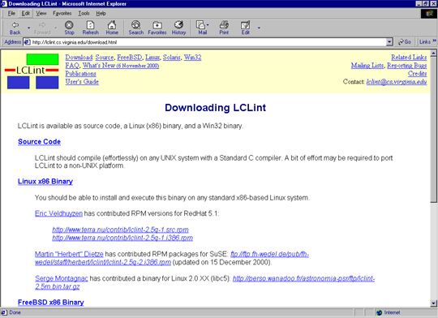
Figure 3.1: Version 1 of the download.html page: Arial font
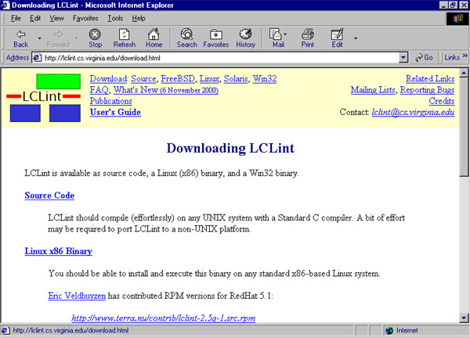
Figure 3.2: Version 2 of the download.html page: Times New Roman font

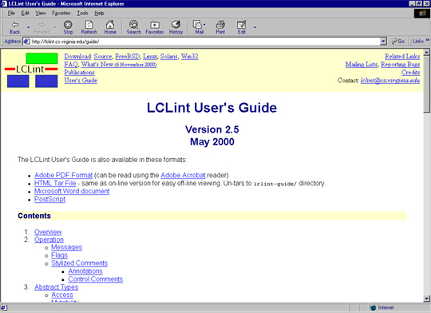
Figure 3.3: Version 1 of the User’s Guide page: Arial Font
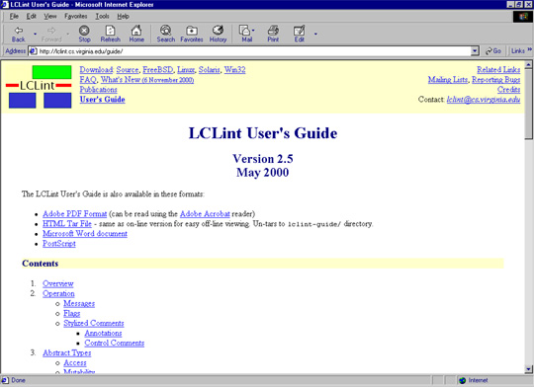
Figure 3.4: Version 2 of the User’s Guide page: Times New Roman font

3.2 The Ideal Quantity of Bold Text
The experiment on font was useful in determining the relative readability of two different fonts; however, it had the disadvantage of only taking into account one factor of usability. A more complex analysis was impossible since I did not know the test subjects or their intentions when using the site. For this reason, I conducted a more tightly-controlled experiment for which I dictated the intentions of my test subjects.
3.2.1 Setup of the Experiment
I conducted my experiment with fourth-year Jennifer Kahng on the students taking CS 110. I created a mirrored version of the CS web site on my machine, and created two versions of the front table of contents page of the site (index.html). I decided to do an experiment to figure out whether bolding links on a page is helpful or harmful to a user’s ability to quickly and accurately find the correct link. My guess was that if some of the links were bolded, users’ eyes would be drawn to these links, and they would be more likely to click them. With increasing bold links, users would be less likely to click them. On version 1 of the page, I bolded 1/8th of the links. On version 2, I bolded 1/4th of them. The next page shows a depiction of each of the versions of the page.
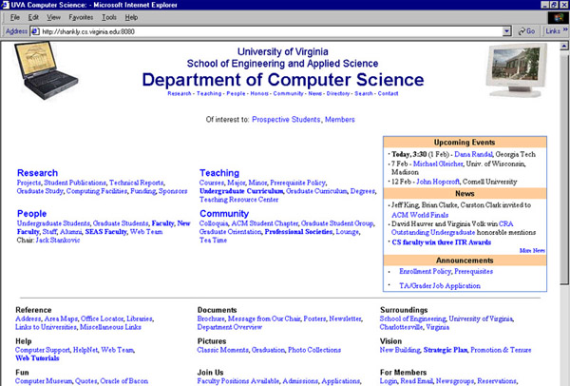
Figure 3.5: Version 1 of the Front Page
Note that 1/8 of links are bolded

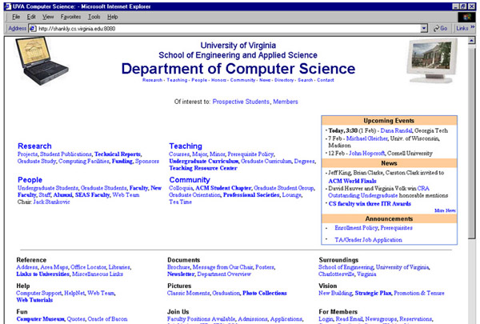
Figure 3.6: Version 2 of the Front Page
Note that 1/4 of links are bolded

I then gave the students a sheet of paper of questions to answer in regard to information on the CS web site. The questionnaire can be found in Appendix A. The questions were selected such that for each question, there was one obvious link to click from the main page to find the answer, but additionally, there were one or two similar, yet incorrect, links which might be clicked were the user not to see the correct link. As an example, one of the questions asked was:
“Which professor is in charge of the Graduate Student Orientation seminar?”
The correct link to click for this question would be “Graduate Orientation”. However, if a user were not to see this link, he may click either “Graduate Students” or “Graduate Curriculum”. Having these distracting links was crucial for determining the visibility of the correct links. I divided the questions such that for about one quarter of them both the correct link and the incorrect link were bold, for another quarter I bolded the correct link but not the incorrect link, for a third quarter I bolded only the incorrect link, and for the rest of them neither were bold. For the page on version 1 I bolded a few more links to make it such that 1/8 were bold. For the page on version 2 I bolded enough such that 1/4 were bold.
Students were forced to use the mirrored version of the web site on fowler to find the answers. Approximately half of the students used machines with odd-numbered IP addresses, and were thus redirected to the version of the front page in which one quarter of the links were bolded. The other half used machines with even-numbered IP addresses, and so were redirected to the page in which one eighth of the links were bolded.
The experiment was to be conducted twice: at 3:15 and at 5:00. Unfortunately, at 3:15 an NFS error caused fowler to crash, and none of the students were able to access it. Between 3:15 and 5:00, with Professor Evans’ and Scott Ruffner’s assistance, Jennifer Kahng and I were able to set up a web server on the server, shankly, and copy everything from fowler over to shankly. Luckily, we were still able to conduct the experiment at 5:00 from shankly.
3.2.2 Results of the Experiment
My results did not show much of a difference in usability between the two pages. I found that the average amount of time spent by users on the front page was the same on each version: 57 seconds. The users’ abilities to accurately choose the correct links was also similar, although for three of the questions, the students who saw the page where ¼ of the links were bold surprisingly found the links with fewer clicks made to incorrect links. This result would make sense for one of the three questions. For this particular question, the incorrect link was bold, but the correct link was not. In this situation, it would make sense that users who saw the page with ¼ bold links would be less affected by the bold, and therefore would be less likely to click the incorrect bold link. However, contrary to common sense, users who saw the page with ¼ bold links also performed better on a question in which the correct link, and not the incorrect link, was bold, and on a question in which neither were bold.
The results of my experiment, unfortunately, must account for a few factors. First, because the first group of students was unable to do the experiment, I lost about 2/3 of my test subjects. The second group only consisted of 11 students. Because of the size of my test population, it may be that users of the page with ¼ bold links may have simply been better at finding information, or may have seen the CS web site before. In addition, it was difficult to trace the paths of the users in the log files. This is because users often did not follow the instructions and answered questions out of order, and because when users visited pages multiple times, the pages cached, so that instead of requesting pages from the server, the computers showed old versions of the pages: these, of course, did not appear in the log file.
My experiments proved that the framework I developed could be useful for comparing the usability of two sets of pages. One experiment allowed me to compare the average amount of time spent on two versions of two specific pages to determine the relative usability of Times New Roman and Arial font. The experiment on bold font was unique in that it allowed me to dictate the users’ goals when using the site. So, in addition to comparing the average amount of time spent on the two pages, I was also able to determine the users’ ability to accurately find links on the pages because I knew their intentions.

Chapter 4.0 Conclusions

Upon completion of the project, I was able to develop a framework to compare the usability of two versions of a web site. For each page in the site, the tool compares the length of time it took users to click a link on the page between two versions of a site. Because the framework analyzes only one factor in web design, it is best used in correlation with other methods of analysis before drawing broad conclusions related to web design.
4.1 Interpretation
Determining the usability of a web site proved to be more of a difficult task than I had originally expected. A user’s reaction to a web page takes into account many factors, most of which are not visible from a log file. For example, one does not know the intended path of the user. Did the user find what he was originally seeking on the site, and was the interface simple enough for him to quickly click the right links to find the information? This information cannot be obtained from a log analysis, but instead would require a tightly controlled usability experiment for which the user would be given a goal, such as the experiment I performed with the students in CS 110.
To add more complexity, many statistics that can be derived from a log analysis have multiple meanings. For instance, some log analysis tools provide a statistic for the number of pages viewed per visit. Yet, if a user views many pages, does this indicate that the user really likes the site, or that the user has a hard time finding the information he is seeking? I chose to analyze the length of time users spent on each page. For pages that require absorbing information, this statistic can also be ambiguous. A user may leave a page quickly because he accidentally found the wrong page and decided to leave, or because the format of the information was simple, and allowed him to absorb the information quickly. Due to this ambiguity, my tool is only useful for table-of-contents pages, for which the user’s intention is to find a link quickly, rather than to absorb information.
Despite the complexity of analyzing usability, I was able to create a tool which proved useful for web design research. Although it only takes into account one factor to perform its analysis, it can be useful in correlation with other methods of analysis for drawing broad conclusions regarding factors in web design which affect a page’s usability.
4.2 Recommendations
The log analysis tool I have created should be useful for anybody who is considering expanding upon the web design research I have done. While there is already a lot of information available regarding web design, the field is new, and there are still many holes to be filled. In addition to performing web design research, my tool is also useful for anybody who wants to upload pages to his own personal site and isn’t sure how the pages should look. He can upload multiple versions of the site at once, and use my application to compare the two versions.
Nevertheless, while log analysis is fast, by itself it is not the most thorough method of determining the usability of web sites. A better method is to perform experiments in which users are given a set of tasks, and are monitored while they complete the tasks. The users may verbalize their thoughts and actions, to provide further information about their reactions to the site. [2:165] The University of Virginia’s Systems Department has an Eye-Gaze system known as ERICA, as well, to track users’ eyes as they read the screen. To quantify a usability experiment, a log analysis can be used in supplement to track the user’s actions and the times at which they occurred. Although it requires more time, an experiment such as this could be conducted to perform a more thorough analysis for determining the characteristics of usable web design.
Works Cited
[1] | Allen, Cliff, Deborah Kania, and Beth Yaeckel. Internet World Guide to One-to-one Web Marketing. New York, NY: John Wiley and Sons, Inc., 1998.
[2] | Forsythe, Chris, Eric Grose, and Julie Ratner, ed. Human Factors and Web Development. Mahwah, NJ: Lawrence Erlbaum Associates, Inc., 1998.
[3] | “The Internet Economy Indicators”, Online, Internet, 24 October 2000, Available: http://www.internetindicators.com/facts.html.
[4] | Lynch, Patrick J., and Sarah Horton. Web Style Guide. New Haven, CT: Yale University Press, 1999.
[5] | Shafron, Andrew. Creating and Enhancing Netscape Web Pages. Indianapolis, IA: Que Corporation, 1996.
[6] | Stout, Rick. Web Site Stats: Tracking Hits and Analyzing Traffic. Berkeley, CA: Osborne McGraw-Hill, 1997.
Bibliography
Allen, Cliff, Deborah Kania, and Beth Yaeckel. Internet World Guide to One-to-one Web Marketing. New York, NY: John Wiley and Sons, Inc., 1998.

Brenner, Steven E., and Edwin Aoki. Introduction to CGI / PERL. New York, NY: M & T Books,1996.

Durrett, H. John, ed. Color and the Computer. Orlando, FL: Academic Press, Inc., 1987.

Forsythe, Chris, Eric Grose, and Julie Ratner, ed. Human Factors and Web Development. Mahwah, NJ: Lawrence Erlbaum Associates, Inc., 1998.

“The Internet Economy Indicators”, Online, Internet, 24 October 2000, Available: http://www.internetindicators.com/facts.html.

Laurie, Ben, and Peter Laurie. Apache: the Definitive Guide. Beijing: O’Reilly & Associates, Inc., 1999.
Lynch, Patrick J., and Sarah Horton. Web Style Guide. New Haven, CT: Yale University Press, 1999.

Nielsen, Jakob. Designing Web Usability. Indianapolis, IA: New Riders Publishing, 2000.

Ninth International World Wide Web Conference, Online, Internet, 12 September 2000, Available: http://www9.org.

Shafron, Andrew. Creating and Enhancing Netscape Web Pages. Indianapolis, IA: Que Corporation, 1996.

Stout, Rick. Web Site Stats: Tracking Hits and Analyzing Traffic. Berkeley, CA: Osborne McGraw-Hill, 1997.

Appendix A: Questionnaire from the Web Usability Experiment

Name____________________

Computer Number___________
(listed on computer as labpc##)

Web Usability Experiment

Please type the following URL into Netscape and bookmark it:
http://fowler.cs.virginia.edu:8080/

Then answer the following questions in order. After each question, return to this URL. If you find yourself spending more than 5 minutes on a question, feel free to skip it.

Please do not consult with anybody on these questions. Just try to answer them to the best of your ability.

1) Who was the original desk czar for the Graduate Student Group?

2) From what university did Professor of Civil Engineering, Furman W. Barton, receive his Ph.D.?

3) Which three CS Faculty members have won ITR awards?

4) Whose office is adjacent to Professor Luebke's office?

5) If you are having a problem with an on-grounds computer outside of business hours, whom should you call first?

6) How many job openings are there for a research scientist in Wide-Area Metasystems?

7) According to the web site, what are the four main reasons why incoming students should choose Computer Science as their major?

8) Which faculty member founded the webteam, and what type of dancing does he consider a hobby?

9) What faculty member is Director of the CS web team and what course is (s)he currently teaching?

10) Who had the original idea for The Oracle of Bacon?

11) Which two professors joined the UVA CS department in 2001?

12) Which professor is in charge of the Graduate Student Orientation seminar?

13) Which computer science courses are undergraduates to take during their fifth semester?

14) In the CS lounge, if you wanted to play the game Vasdasz a 2x3x2 Colored Sliding Puzzle, would you be able to find it?

